

Al-Yamamah University

College of Engineering and Architecture

Department of Network Engineering and Security

**Graduation Project**

**CyberLab**

**Presented by**

Talal alharthi (202111264)

Nawaf alsowaine (202111330)

Abdulmajeed albaltan (201611024)

**Supervised by**

Ms. Firdaous Bouzegza

**Spring Semester**

Academic Year 2023/2024

**Table of Content**

Chapter 1 3

1 Introduction 3

2 Problem statement 3

3 Project definition 3

4 Background research 4

5 Objectives 6

6 Limitations 6

7 Question of the thesis 7

8 Significance 7

9 Project plan 9

Chapter 2 11

1 2d games 11

1.1 Cyber adventure 11

1.2 Space shelter 13

2 3d games 15

2.1 Interland 15

3 Web base games 16

3.1 Cybersecurity lab 16

3.2 Keep traditional secure 18

4 Mobile games 20

4.1 Defend the crown 20

4.2 Network collapse 22

5 Pc games 23

5.1 ThreatGEN Red vs. Blue 23

5.2 Cyber attack game 25

5.3 Cyber ops 27

6 Courses 30

7 Videos 31

8 Our game 32

Chapter 3 37

1 Introduction 38

2 User characteristics 38

3 Functional Requirements 38

4 Non-Functional Requirements 39

5 Software Requirements 39

6 Hardware Requirements 40

7 Use-case Diagram 41

8 Use-case description 42

9 Interaction diagrams 47

l10 Flow chart 49

l11 Class digram 50

l12 Database design 51

l13 ERD diagram 52

l14 Database Schema 53

l15 Prototype 54

l16 conclusion 59

Chapter 4 60

1 Tools used to develop the project 61

2 code snippets 62

3 Test cases 62

Chapter 5 64

Chapter 6 66

1 Conclusion: 67

2 Suggestions for Future Research 67

lAppendix 68

Reference 72

**Table of figures:**

Figure 1 main menu 16

Figure 2 sign in 17

Figure 3 inside game 17

Figure 4 main menu 19

Figure 5 game quizzes 19

Figure 6 game category 19

Figure 7 main menu 21

Figure 8 game category 21

Figure 9 inside game 22

Figure 10 main menu 23

Figure 11 game quizzes 24

Figure 12 inside game 24

Figure 13 main menu 25

Figure 14 game quizzes 26

Figure 15 inside game 26

Figure 16 main menu 28

Figure 17 game category 28

Figure 18 inside game 28

Figure 19 main menu 30

Figure 20 game tutorial 30

Figure 21 inside game 30

Figure 22 main menu 32

Figure 23 game category 32

Figure 24 inside game 33

Figure 25 main menu 34

Figure 26 game category 35

Figure 27 inside game 35

Figure 28 start of game 37

Figure 29 game tutorial 37

Figure 30 game challenge 37

Figure 31 inside game 38

Figure 32 courses about our game topics 40

Figure 33 videos about our game topics 41

Figure 34: Use-case Diagram 54

Figure 35 sequence diagram for admin 60

Figure 36 sequence diagram for player 62

Figure 37 flow chart of our game 62

Figure 38 class diagram of our game 63

Figure 39 database design of our game 64

Figure 40 ERD diagram 65

Figure 41 main menu 67

Figure 42 log in 67

Figure 43 sign up 68

Figure 44 tutorial 68

Figure 45 training level 69

Figure 46 main game page 69

Figure 47 level page 70

Figure 48 failed page 70

Figure 49 success page 71

Figure 50 loading page 71

Figure 51 Register & Log-in code 76

Figure 52 sign in code 77

Figure 53 signup code 78

Figure 54 signup code 78

Figure 55 signup code 79

Figure 56 data manager code 80

Figure 57 gamedata code 81

Figure 58 save data code 81

Figure 59 reset gamedata code 82

Figure 60 loading data code 83

Figure 61 survey questions 90

Figure 62 survey questions 90

Figure 63 survey questions 91

Figure 64 survey "age" 92

Figure 65 familiarity with cybersecurity threats 93

Figure 66 helpfulness of educational cybrsecurity games 94

Figure 67 usage of educational cybersecurity games 94

**CHAPTER 1: INTRODUCTION:**

**1.1-Introduction:**

We live in a world where technology is an integral part of our lives. It has brought us incredible convenience and connectivity, but it has also introduced new risks and challenges. Cyber security has become increasingly important as cyber threats and attacks continue to rise. It is essential to educate people, especially young individuals, about the potential dangers and how to protect themselves online. That's why this graduation project focuses on developing an educational cybersecurity game. By blending interactive gameplay with fundamental cybersecurity concepts and practices, we aim to make learning about cybersecurity engaging and enjoyable.

**1.2-Problem statement:**

In today's digital world, cyber threats are becoming more frequent and sophisticated, posing a significant risk to individuals, organizations, and society as a whole. Unfortunately, many people, especially young individuals, lack the knowledge and awareness needed to protect themselves effectively against these cyber-attacks. Traditional methods of cyber security education, such as lectures and textbooks, often fail to engage students and result in limited understanding and retention of important concepts. This calls for innovative and interactive approaches to educate people about cyber security in a way that is engaging, practical, and easily accessible.

**1.3-Project definition:**

The goal of this graduation project is to tackle the aforementioned problem by developing an educational cybersecurity game. We aim to create an exciting and immersive learning experience that combines the thrill of gaming with essential cybersecurity knowledge and skills. The game will be targeted to ages 13-30 and toward beginners who have an interest in learning about cybersecurity, providing them with an engaging platform to learn about various aspects of cybersecurity, including recognizing threats, adopting safe online practices, safeguarding personal data, and responding to incidents.

To ensure the game's effectiveness, we will conduct thorough research on cybersecurity concepts, threats, and best practices. This will enable us to create accurate and relevant content for the game. Our comprehensive game design will incorporate different levels, challenges, and educational resources to enhance the learning experience. Throughout the development process, we will gather user feedback and conduct testing to ensure that the game is user-friendly and achieves its educational objectives.

By developing an educational cyber security game, our project aims to bridge the gap between theory and practice. We want to empower users with the necessary skills and awareness to navigate the digital landscape securely. To measure the success of our project, we will evaluate the game's impact on users' cyber security knowledge, behavior, and attitudes. Ultimately, our goal is to contribute to a safer online environment by equipping individuals, with the tools they need to protect themselves and their digital assets from cyber threats.

**1.4-Background research:**

Areas to focus on during the background research phase:

1. Understanding cyber security concepts:

It's essential to grasp the basics of cyber security, such as different types of cyber threats like malware, phishing, and hacking. Dive into topics like encryption, authentication, network security, and data privacy. This knowledge will help effectively communicate these concepts in the game.

2. Examining real-world cyber threats:

Stay updated on the latest trends and developments in the cyber threat landscape. Read about recent cyber-attacks, data breaches, and emerging threats. Analyze case studies and real-world examples to understand how these attacks impact individuals, organizations, and society. This understanding will enable the creation of realistic scenarios and challenges in the game.

3. Understanding the target audience:

Identify the people to reach with the educational cyber security game. Are the targets students, young adults, or specific age groups? Get to know their characteristics, behaviors, and preferences when it comes to gaming and cyber security. By understanding their motivations, interests, and learning styles, we can design a game that engages and educates them effectively.

4. Exploring gamification and learning theory:

Study gamification principles and techniques that can be applied to the educational game. Look into the psychological and educational theories that underpin effective game-based learning, such as motivation, engagement, scaffolding, and feedback. Look at successful examples of gamified learning experiences in other fields to gain valuable insights.

5. Defining educational objectives and aligning with curricula:

Clearly define the educational goals of the game based on the desired learning outcomes. Align these objectives with relevant cybersecurity frameworks, standards, and curricula, such as those used by educational institutions, industry certifications, or government initiatives. Make sure the game covers essential topics and adheres to established educational guidelines.

6. Designing a user-friendly experience and interface:

Research user experience (UX) and user interface (UI) design principles for game development. Discover best practices for creating interfaces that are intuitive, visually appealing, and enhance engagement and ease of use. Consider accessibility and inclusivity factors to ensure that a diverse range of users can enjoy the game.

7. Considering ethical and legal factors:

Understand the ethical and legal aspects of cyber security, including privacy laws, data protection regulations, and ethical hacking practices. Ensure that the game promotes responsible and ethical behavior in the digital realm while respecting legal boundaries.

8. Evaluating effectiveness and learning outcomes:

Explore different methods for evaluating the effectiveness of educational games. Look into assessment techniques like quizzes, challenges, and performance tracking to measure players' learning outcomes and progress. Familiarize with the existing frameworks or guidelines for evaluating the impact of educational games on cybersecurity knowledge and behavior.

By conducting thorough background research in these areas, gather the necessary knowledge and insights to develop an engaging and effective educational cybersecurity game. This research will serve as the foundation for creating accurate and relevant game content, incorporating gamification principles, and aligning with educational objectives and the needs of the target audience.

**1.5-Objectives:**

1. Develop an engaging and interactive educational cybersecurity game that effectively conveys essential concepts and practices to the target audience.

2. Incorporate real-world cyber threats and scenarios into the game to enhance the authenticity and relevance of the learning experience.

3. Ensure the accuracy and up-to-date information within the game's content by conducting thorough research on cybersecurity concepts, emerging threats, and best practices.

4. Design the game in a user-friendly manner, considering the target audience's preferences, age group, and gaming habits to maximize engagement and learning outcomes.

5. Evaluate the effectiveness of the educational game by conducting user testing and gathering feedback to measure the game's impact on participants' knowledge and awareness of cybersecurity.

**1.6-Limitations:**

While we're excited about developing an educational cybersecurity game for our graduation project, it's important to acknowledge a few limitations that may impact our project's scope and implementation. Here are some of the challenges we may encounter:

1. Time constraints: We have a specific timeline for our graduation project, which means we might have limited time for developing, testing, and refining the game. This might affect the depth and complexity of the game's content and features.

2. Resource limitations: Our project might have budgetary or resource constraints, which could impact our ability to create advanced graphics, animations, or interactive elements within the game. This might affect the overall user experience and engagement.

3. Technical limitations: Developing a complex educational game may require specialized programming skills or software tools that might not be readily available or within our project's scope. Technical limitations could affect the game's functionality and performance.

4. Target audience considerations: The effectiveness of our game might vary based on the prior knowledge, learning preferences, and access to the technology of our target audience. Catering to a wide range of users with different skill levels and educational backgrounds can be challenging.

5. Evaluation challenges: Assessing the impact of our game on knowledge acquisition and cybersecurity awareness might be challenging. We might face limitations in accessing a diverse sample of participants or measuring long-term learning outcomes effectively.

6. Evolving cybersecurity landscape: The field of cybersecurity is constantly changing, with new threats, technologies, and best practices emerging frequently. Keeping up with the latest trends and incorporating them into our game might be challenging given our project's timeline.

Despite these limitations, we're committed to overcoming them by leveraging available resources, conducting thorough research, collaborating with experts, and implementing effective project management strategies. Our goal is to deliver a valuable educational cybersecurity game within the given constraints.

**1.7-Question of the thesis:**

What is the effectiveness of an educational cybersecurity game in enhancing knowledge acquisition and promoting awareness of cybersecurity among the target audience?

**1.8-Significance:**

A graduation project focused on an educational cybersecurity game is important for several reasons:

1. Meeting the increasing demand for cybersecurity education: In today's digital world, cybersecurity is crucial. By creating an educational game, the project helps address the need for better cybersecurity knowledge and awareness among individuals and organizations.

2. Making learning fun and engaging: Traditional cybersecurity education methods can be boring and unengaging, leading to limited retention. The game offers an interactive and immersive learning experience that encourages active participation, critical thinking, and problem-solving.

3. Closing the gap between theory and practice: The project aims to bridge the divide between theoretical cybersecurity knowledge and its practical application. By incorporating real-world cyber threats and challenges, users can gain practical insights and develop skills to protect themselves and their digital assets.

4. Increasing accessibility and reach of cybersecurity education: An educational cybersecurity game has the potential to reach a wide audience, including students, professionals, and individuals with varying levels of technical expertise. The game's scalability enables widespread distribution, making cybersecurity education more accessible to diverse populations.

5. Evaluating the effectiveness of gamified learning: The project provides an opportunity to assess how gamified learning impacts cybersecurity education. Through evaluation and feedback, the project can contribute to understanding how games enhance knowledge acquisition, retention, and behavior change in cybersecurity.

6. Driving innovation in cybersecurity education: By exploring new approaches, technologies, and methodologies in educational game development, the project can inspire innovation in cybersecurity education. Insights gained from the project may lead to advancements and improvements in educational tools and methods.

Overall, the graduation project on an educational cybersecurity game has significant value in the field of cybersecurity education. Its aim is to empower individuals with the knowledge, skills, and awareness needed to navigate the digital world securely.

**1.9-Project plan:**

|  |  |  |  |  |  |  |  |  |  |  |  |  |
| --- | --- | --- | --- | --- | --- | --- | --- | --- | --- | --- | --- | --- |
| **PROJECT SCHEDULE** | **Week 8**  **3-7 March** | **Week 9**  **7-13 March** | **Week 10**  **16-20 March** | **Week 11**  **23-27 March** | **Week 12**  **30 March**  **– 3 April** | **Week 13**  **6-10 April** | **Week 14**  **13-17 April** | **Week 15**  **20-24 April** | **Week 16**  **27 April**  **– 1 May** | **Week 17**  **4-8 May** | **Week 18**  **11-15**  **May** | **Week 19**  **18-22 May** |
| PROJECT PROPOSAL |  |  |  |  |  |  |  |  |  |  |  |  |
| CHAPTER 1 INTRODUCTION |  |  |  |  |  |  |  |  |  |  |  |  |
| CHAPTER 2 LITERATURE REVIEW |  |  |  |  |  |  |  |  |  |  |  |  |
| CHAPTER 3 METHODOLOGY AND DESIGN |  |  |  |  |  |  |  |  |  |  |  |  |
| REVIEWING CHAPTERS  1-3 |  |  |  |  |  |  |  |  |  |  |  |  |
| PREPARE FOR PRESENTATION |  |  |  |  |  |  |  |  |  |  |  |  |
| PRESENTASION |  |  |  |  |  |  |  |  |  |  |  |  |

**CHAPTER 2**

**LITERATURE REVIEW**

**2.1-: Literature Review and Related Work**

We can learn and educate about cybersecurity from games or courses or videos so we have searched for some games related to our topic cybersecurity and we found different games in different platforms and categories we will show them in these categories:

2D GAMES:-

**2.1.1-Cyber Adventure**:

Objective: The CyberAdventure Game is designed to teach children aged 7-12 about online safety through interactive play. It simulates various internet risks such as cyberbullying, harassment, and data protection violations, encourages children to learn and practice safe online behavior and educates them on the dangers of the internet, and promotes responsible digital conduct.

Introduction: Cyber adventure provides immersive experiences with a focus on cyber themes, involving exploration, puzzle-solving, and strategic decision-making.

A-Gameplay Mechanics:

The game will work by exploration, puzzle-solving, NPC interactions, and elements of stealth, hacking, and strategy and features like mini-games, inventory management, and branching storylines.

B. Narrative Elements:

The game has themes of technology, AI, virtual reality, and futuristic societies, and storylines include uncovering conspiracies and battling oppressive systems.

C. Player Engagement and Immersion:

The game has detailed graphics and sound design for a sense of presence and emotional connections with characters and a sense of accomplishment.

D. Impacts and Benefits:

The game Impacts in Short-term are Entertainment, stress relief, cognitive stimulation and in Long-term are Fosters creativity and personal growth through problem-solving.

Some pictures of game:

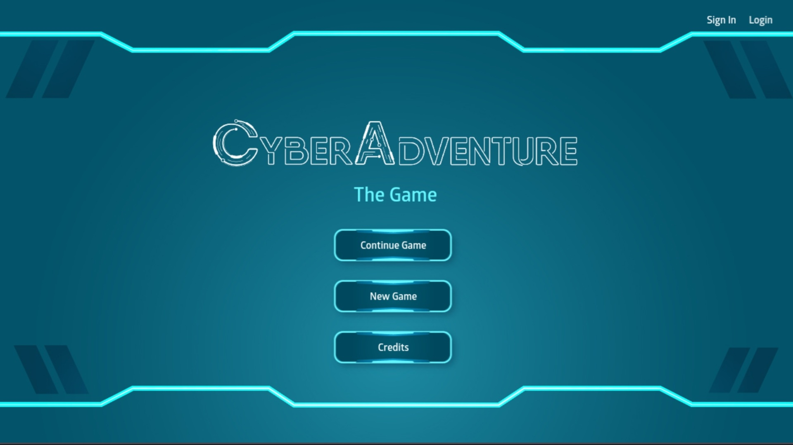

Figure 1 main menu

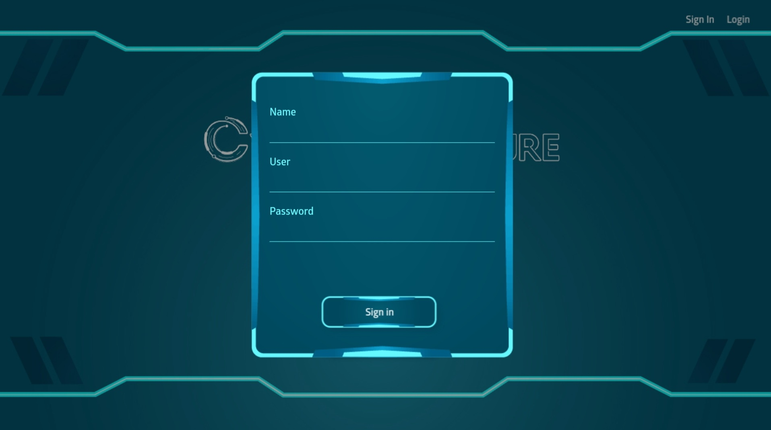

Figure 2 sign in

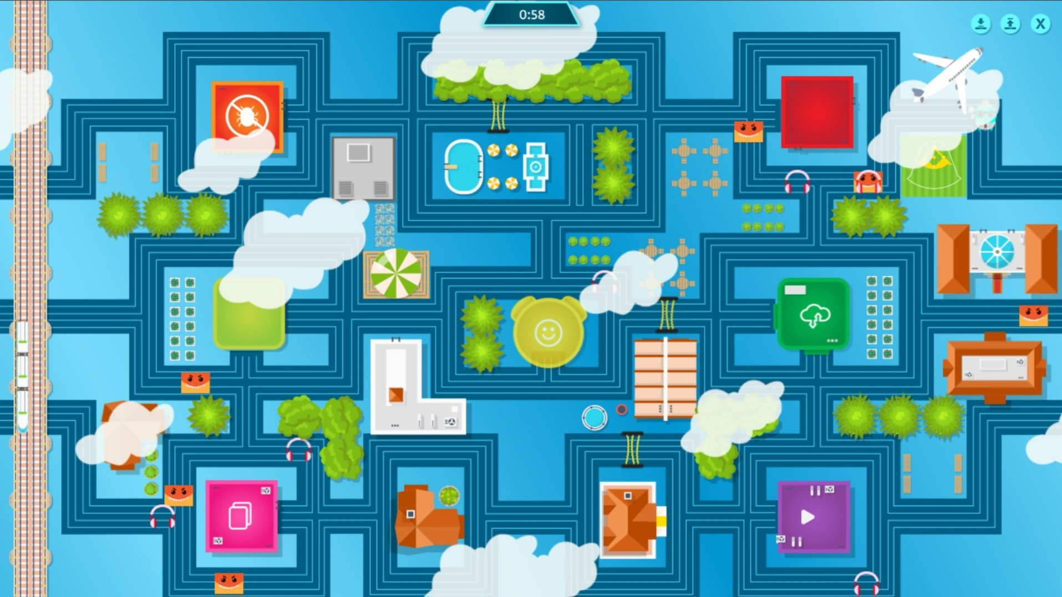

Figure 3 inside game

**2.1.2-Space shelter:**

Introduction: Space shelter game simulate the experience of building and managing space colonies, incorporating survival, resource management, and exploration.

A. Gameplay Mechanics:

The game works by player manage resources, construct facilities, and ensure colony survival against the cyber attack and elements of exploration and encounters with challenges like asteroids and aliens and education about cybersecurity.

B. Educational Value:

The value of the game is developing skills in resource management and strategic planning and enhancing knowledge of space science through scientific concepts. educate about cybersecurity skills through interactive gameplay.

C. Community and Modding:

The effects of modding the game on community are Thriving player communities share strategies and mods and Modding extends game lifespan and allows customization.

D. Future Developments:

The future developments will affect the game by Potential for VR/AR technologies for immersive experiences, and AI advancements could improve gameplay dynamics and colony management.

Conclusion: Space shelter games offer a blend of simulation, strategy, and exploration, with educational value and the potential for technological advancements enhancing player engagement and interest in space exploration and cybersecurity skills.

Some pictures:



Figure 4 main menu

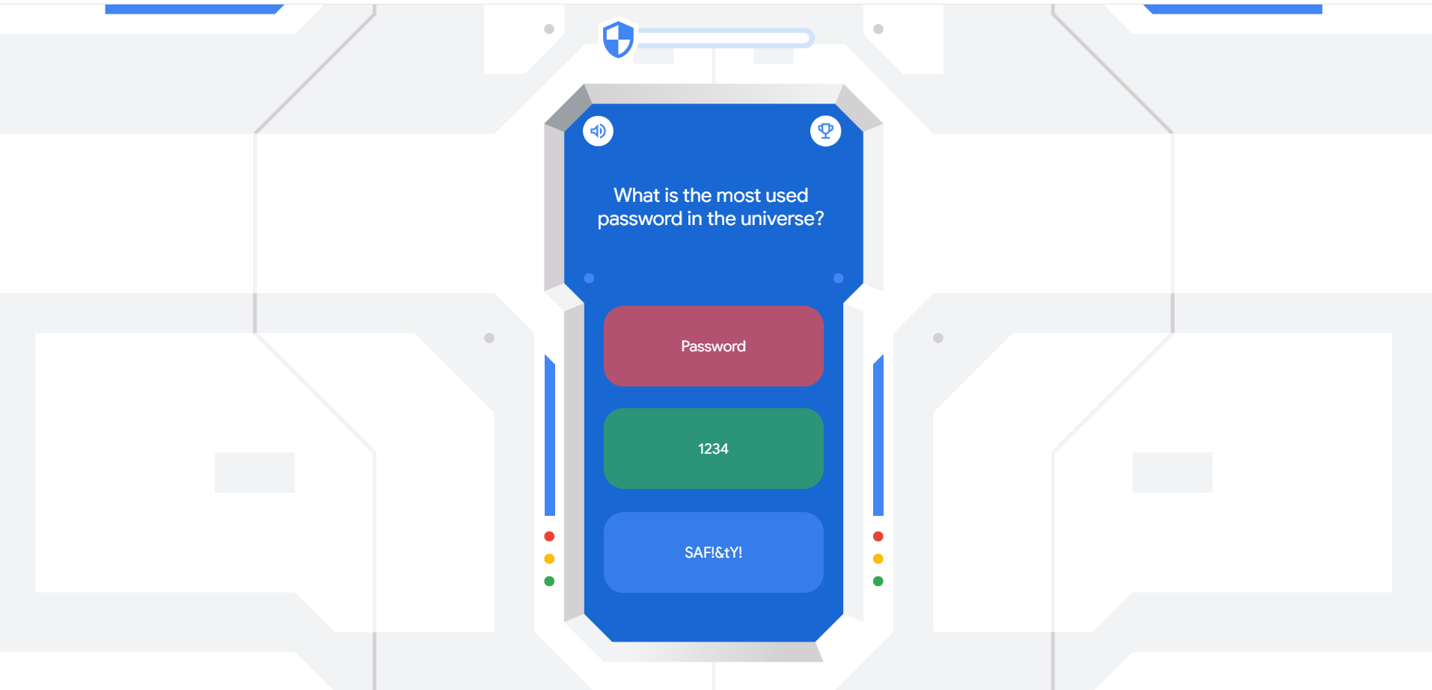

Figure 5 game quizzes

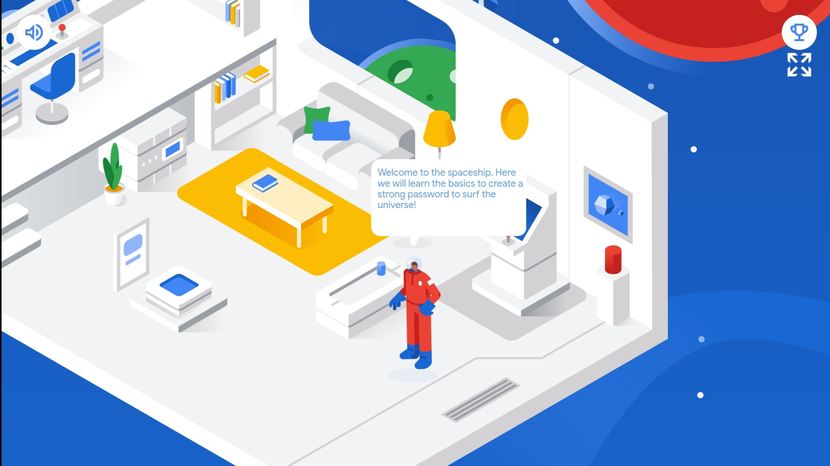

Figure 6 game category

3D GAMES:-

**2.1.3-Interland**:

**Introduct**ion: Interland is an educational game by Google designed to teach children about online safety and digital citizenship through interactive gameplay.

A. Purpose:

The game target to educating on digital citizenship and online safety and addressing topics like privacy, cyberbullying, and phishing.

B. Gameplay Mechanics:

The game works by interactive levels representing digital citizenship aspects, Problem-solving, exploration, and quizzes to learn safety concepts.

C. Educational Value:

The values of the game are to teach digital literacy skills and responsible online behavior and combine gameplay with scenarios for practical decision-making.

D. Impact on Digital Literacy:

The game impacts digital literacy by providing a safe environment to learn about online risks , encouraging critical thinking, and reinforcing positive online behavior.

E. Integration and Accessibility:

The game can be integrated into educational curricula and safety programs and features multilingual support and adaptive gameplay for diverse users.

Conclusion: Interland is a key educational resource that effectively teaches essential digital literacy skills, promoting safe and responsible internet use among children.

Some pictures:

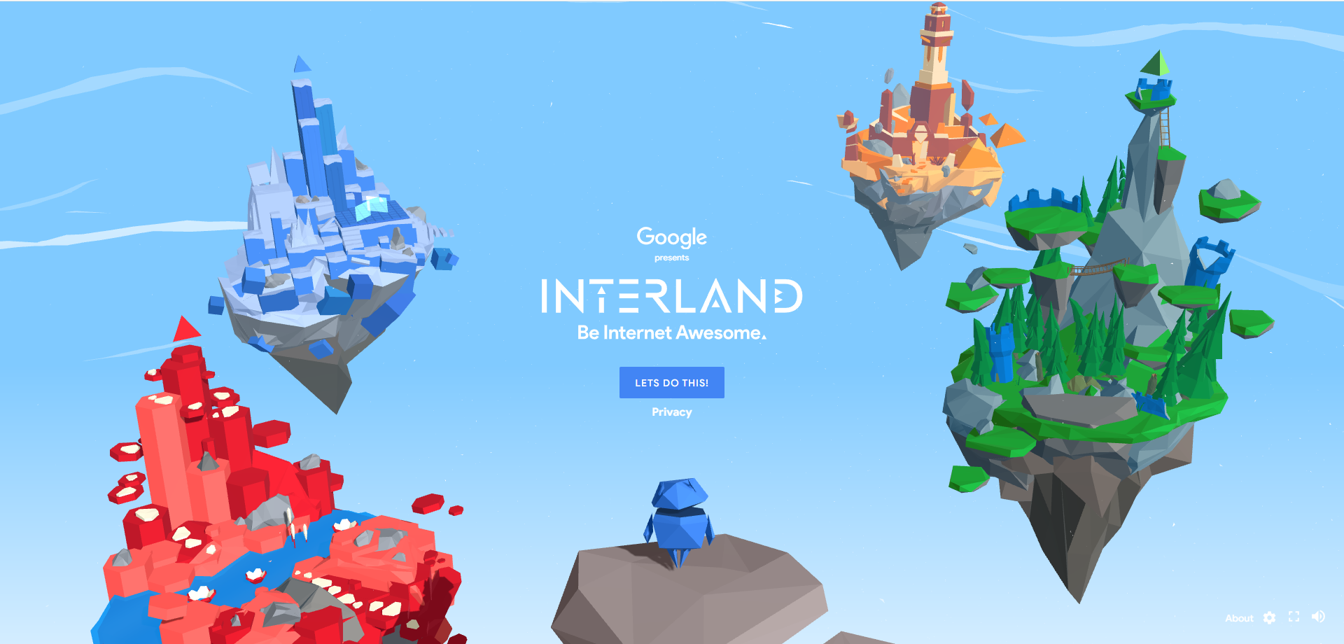

Figure 7 main menu

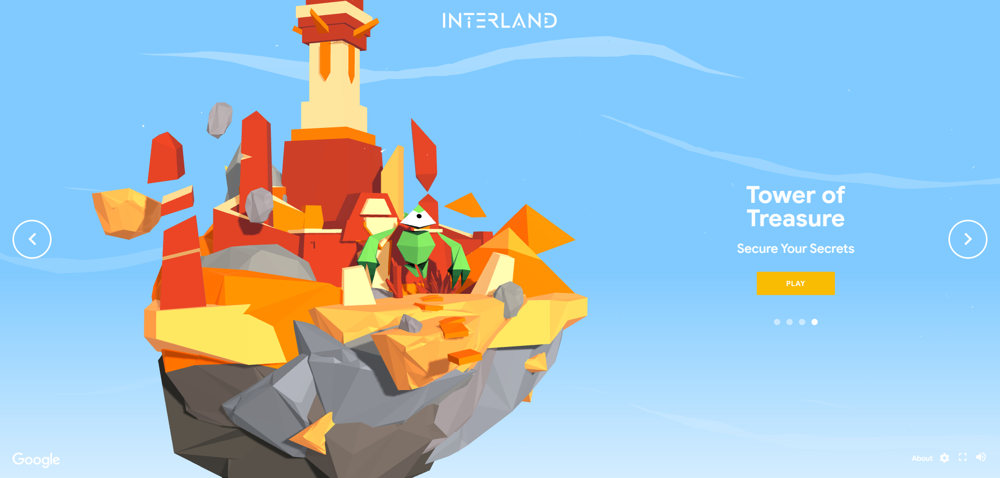

Figure 8 game category

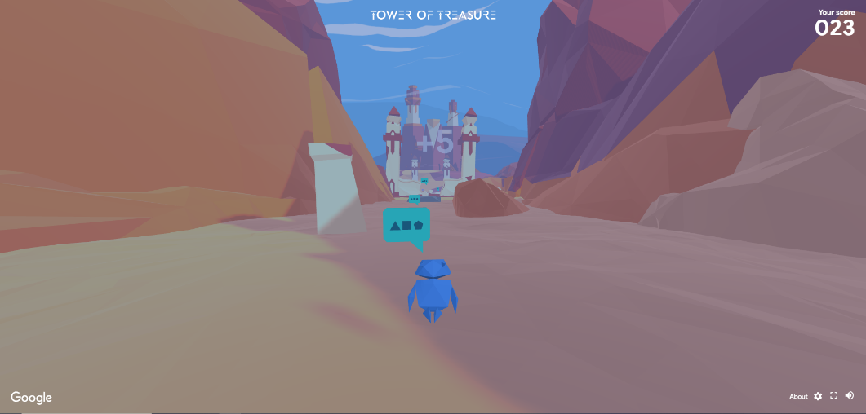

Figure 9 inside game

WEB BASED GAMES:-

**2.1.4-Cybersecurity Lab**:

**Introduction: Cyb**ersecurity Lab is an interactive game by NOVA Labs that educates players on cybersecurity through gameplay.

A. Purpose:

The game targets to teach cybersecurity principles in a simulated environment, and players learn about encryption, network security, and more.

B. Gameplay Mechanics:

The game works by combining problem-solving, decision-making, and experimentation, and players use tools to secure a virtual network from cyber threats.

C. Educational Value:

The values of the game are to offer hands-on experience in cybersecurity scenarios and develop practical knowledge and problem-solving skills.

D. Impact on Knowledge and Skills:

The game impacts are enhanced understanding of cybersecurity concepts and practices and encouraging critical thinking and strategy development.

E. Integration into Education:

The game can supplement cybersecurity education and training and adaptable for various learning objectives and settings.

Conclusion: Cybersecurity Lab provides an educational platform for learning cybersecurity, combining interactive gameplay with practical skill development.

Some pictures:

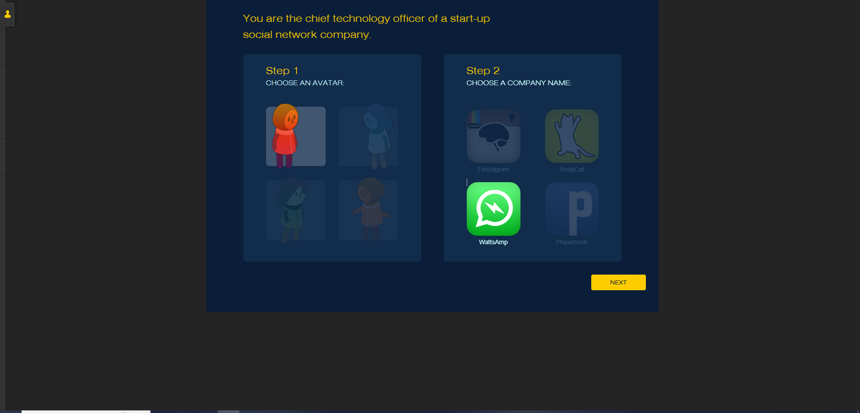

Figure 10 main menu

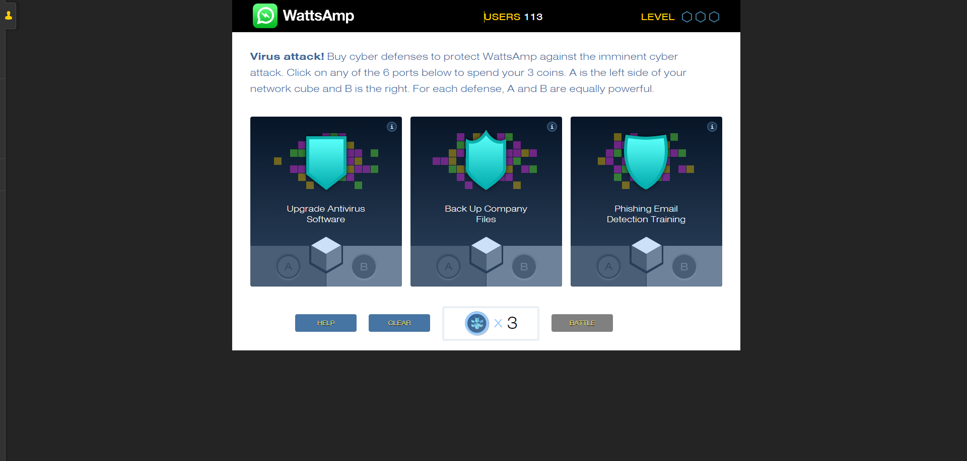

Figure 11 game quizzes

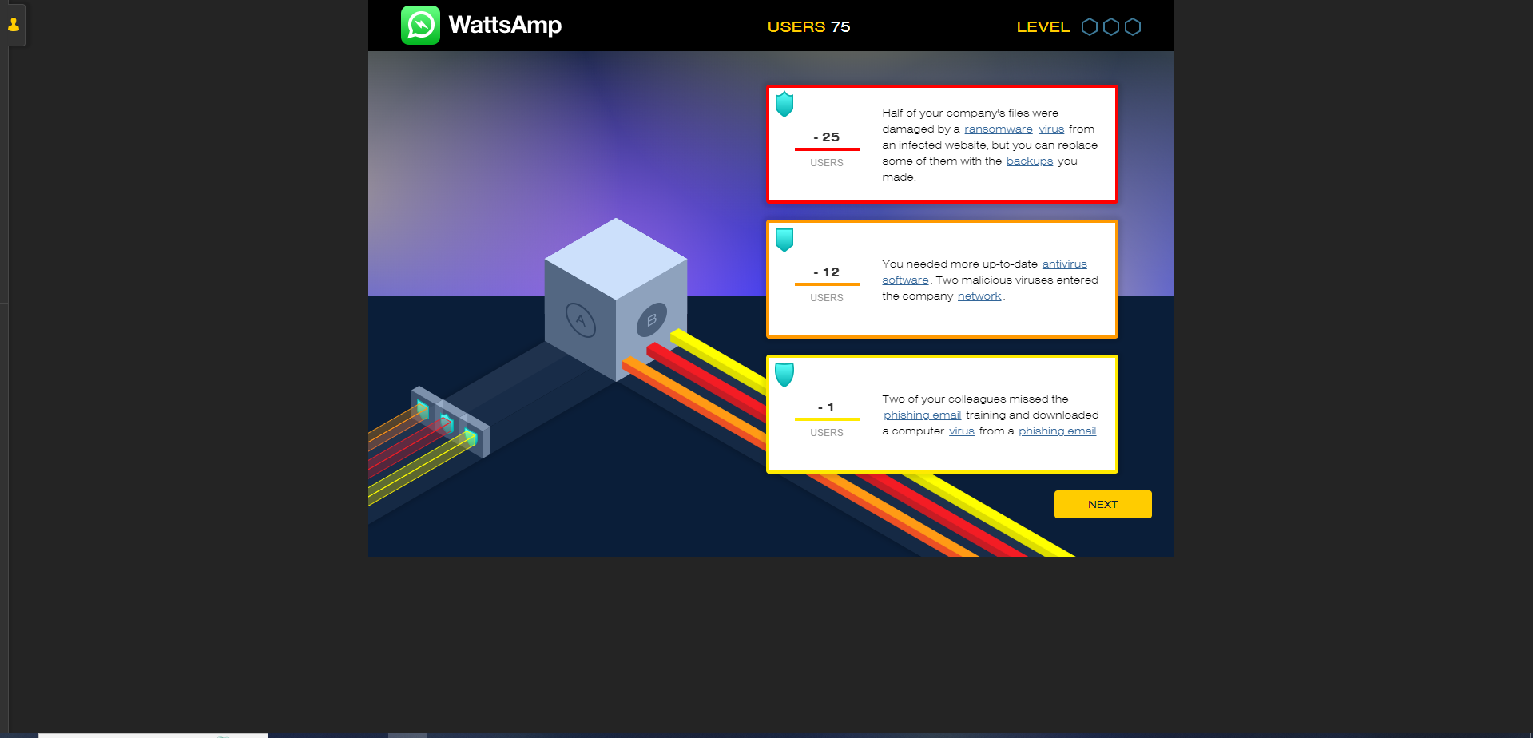

Figure 12 inside game

**2.1.5-keep tradition secure:**

Introduction: Keep Tradition Secure is an educational game focused on cybersecurity within cultural heritage preservation.

A. Purpose:

The game targets to educate on cybersecurity challenges in cultural heritage and promotes security measures to protect digital cultural assets.

B. Gameplay Mechanics:

The game works by simulation scenarios faced by cultural heritage institutions, and players protect assets from cyber threats like data breaches and ransomware.

C. Educational Value:

The values of the game are Combines cybersecurity awareness with cultural heritage preservation and Teaches risk assessment, incident response, and data protection.

D. Impact on Knowledge and Preservation:

The impacts of the game are enhancing understanding of cybersecurity in cultural heritage contexts and encouraging the adoption of best practices to safeguard cultural assets.

E. Collaboration and Engagement:

The game will engage fosters partnerships between cybersecurity and cultural heritage professionals and promote knowledge exchange and the development of protective solutions.

Conclusion: Keep Tradition Secure effectively raises awareness about the importance of cybersecurity in preserving cultural heritage, offering an engaging learning experience through interactive gameplay.

Some pictures:



Figure 13 main menu

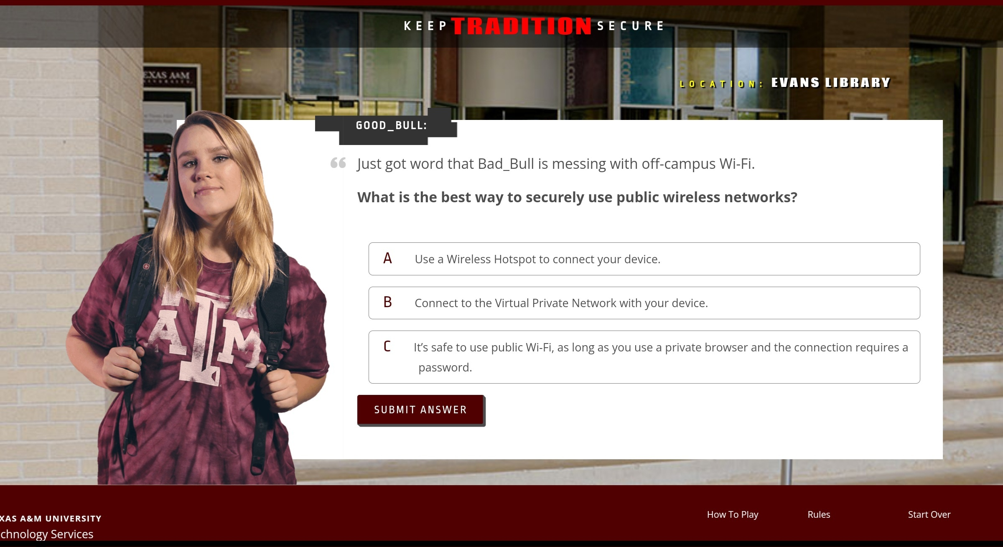

Figure 14 game quizzes

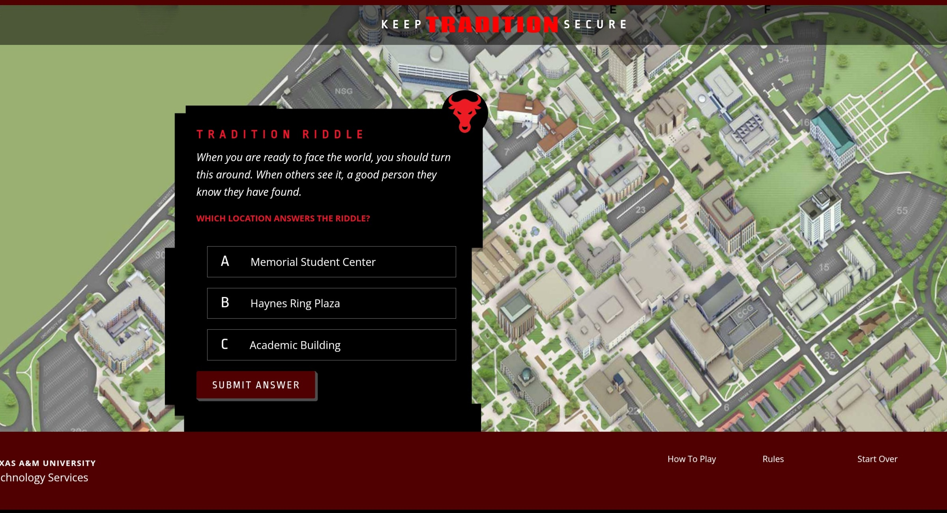

Figure 15 inside game

MOBILE GAME:-

**2.1.6-Defend the Crown**:

Introduction: Defend the Crown is a strategic tower defense game that challenges players to protect a kingdom’s crown from invaders.

A. Purpose:

The game targets to engage players in strategic decision-making and defense planning and aims to enhance strategic thinking and problem-solving skills.

B. Gameplay Mechanics:

The game works in features strategic placement of towers and defensive structures and includes an upgrade system for enhancing tower capabilities.

C. Immersive Features:

The features of the game are appealing graphics, sound effects, and engaging storyline are dynamic gameplay elements that require quick thinking and adaptation.

D. Impact on Skills:

The game positively affects strategic thinking, and decision-making abilities encourage players to analyze and adapt to challenging scenarios.

E. Educational Potential:

The game educational impacts align with skills applicable in business, leadership, and management and fosters critical thinking and analytical skills through gameplay.

Conclusion: Defend the Crown provides an immersive gaming experience that enhances strategic thinking and decision-making, with potential educational benefits in real-world applications.

Some pictures:

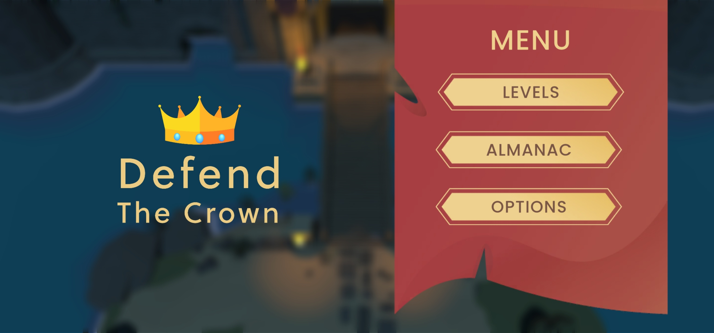

Figure 16 main menu

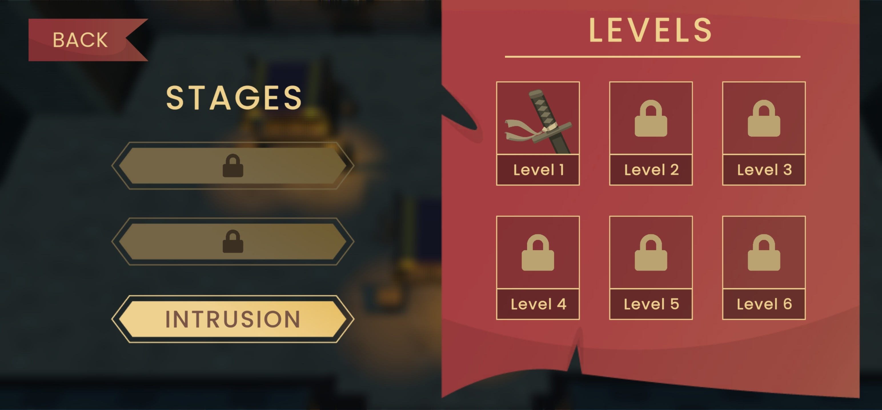

Figure 17 game category

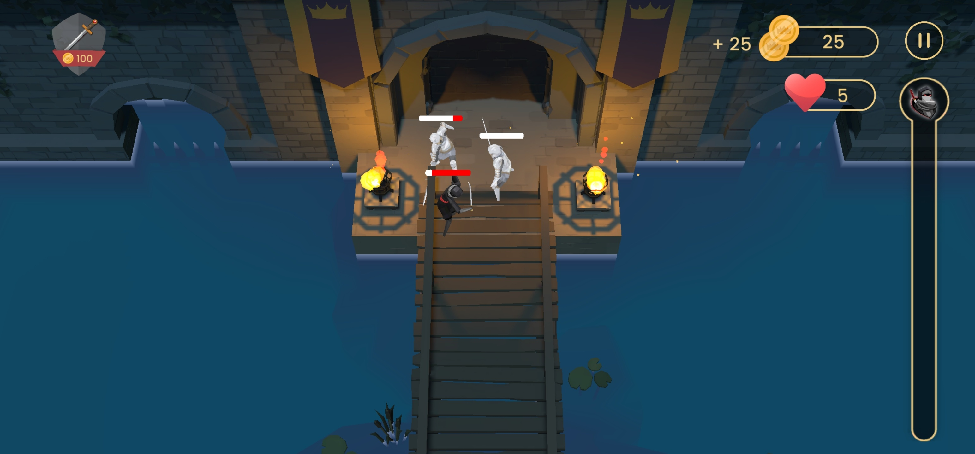

Figure 18 inside game

**2.1.7-Network Collapse**:

Introduction: Network Collapse is a strategic simulation game that immerses players in the challenges of restoring network functionality after a collapse.

A. Purpose:

The game targets to simulate network collapse scenarios for realistic experience and teaches troubleshooting, vulnerability identification, and remediation.

B. Gameplay Mechanics:

The game works by players diagnosed and resolving network problems using various tools and strategic decision-making on network configurations, and security is key.

C. Educational Value:

The values of the game are provided hands-on learning in network troubleshooting and management and develop problem-solving skills and understanding of network systems.

D. Impact on Skills:

The impacts of the game are enhancing problem-solving and network management abilities and encouraging critical thinking, and informed decision-making under pressure.

E. Integration into Training:

The game can be integrated into network administration training programs and offers practical experience to complement theoretical knowledge.

Conclusion: Network Collapse offers an educational platform that enhances problem-solving and network management skills through strategic gameplay and simulated challenges.

Some pictures:

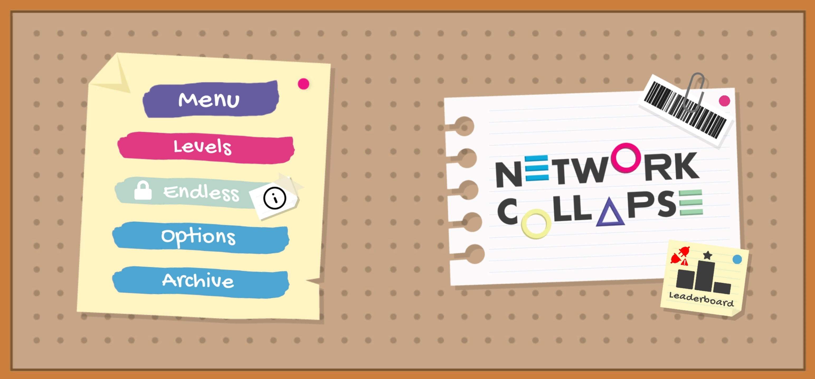

Figure 19 main menu

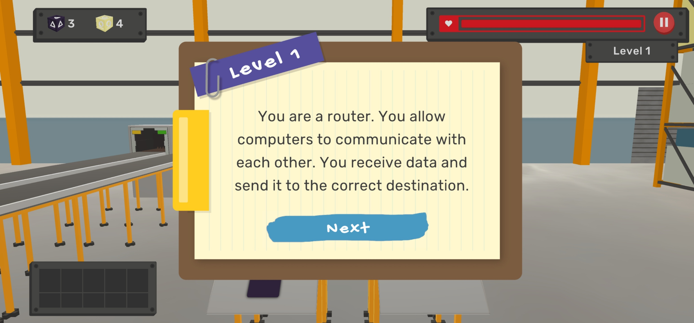

Figure 20 game tutorial

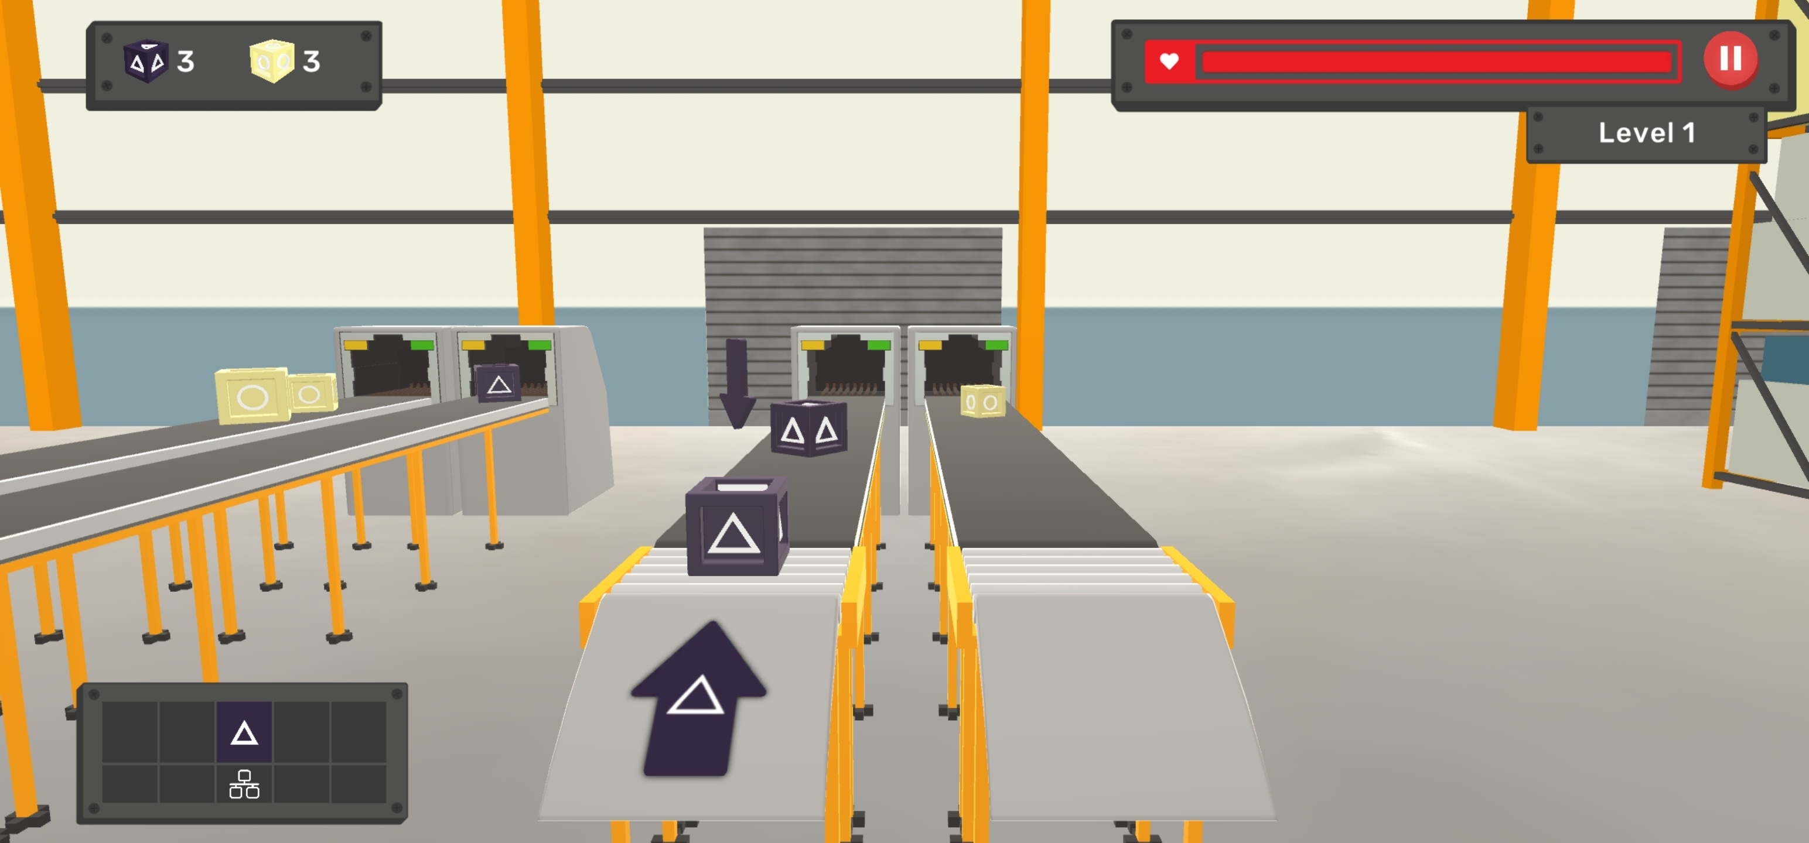

Figure 21 inside game

PC GAMES: -

**2.1.8-ThreatGEN: Red vs. Blue**:

**Introduction: ThreatGEN**: Red vs. Blue is a cybersecurity simulation game that emulates the dynamics of cyber attacks and defenses.

A. Purpose:

The game targets to provide a realistic experience of offensive and defensive cybersecurity operations and enhances understanding of cyber threats and defense strategies.

B. Gameplay Mechanics:

The game works by dividing players into Red Team (attackers) and Blue Team (defenders) and emphasizes teamwork, communication, and strategic decision-making.

C. Educational Value:

The game values are offering hands-on learning in cybersecurity and developing skills in vulnerability assessment, penetration testing, and incident response.

D. Impact on Cybersecurity Skills:

The game impacts are improving critical thinking, problem-solving, and technical proficiency and preparing players for real-world cybersecurity challenges.

E. Real-World Relevance:

The game is relevant to the real world through stimulating realistic cyber operations, bridging the gap between theory and practice, and transferring experiences to real-world cybersecurity operations.

Conclusion: ThreatGEN: Red vs. Blue provides an immersive educational experience, enhancing players’ cybersecurity skills and strategic understanding through simulated cyber operations.

Some pictures:

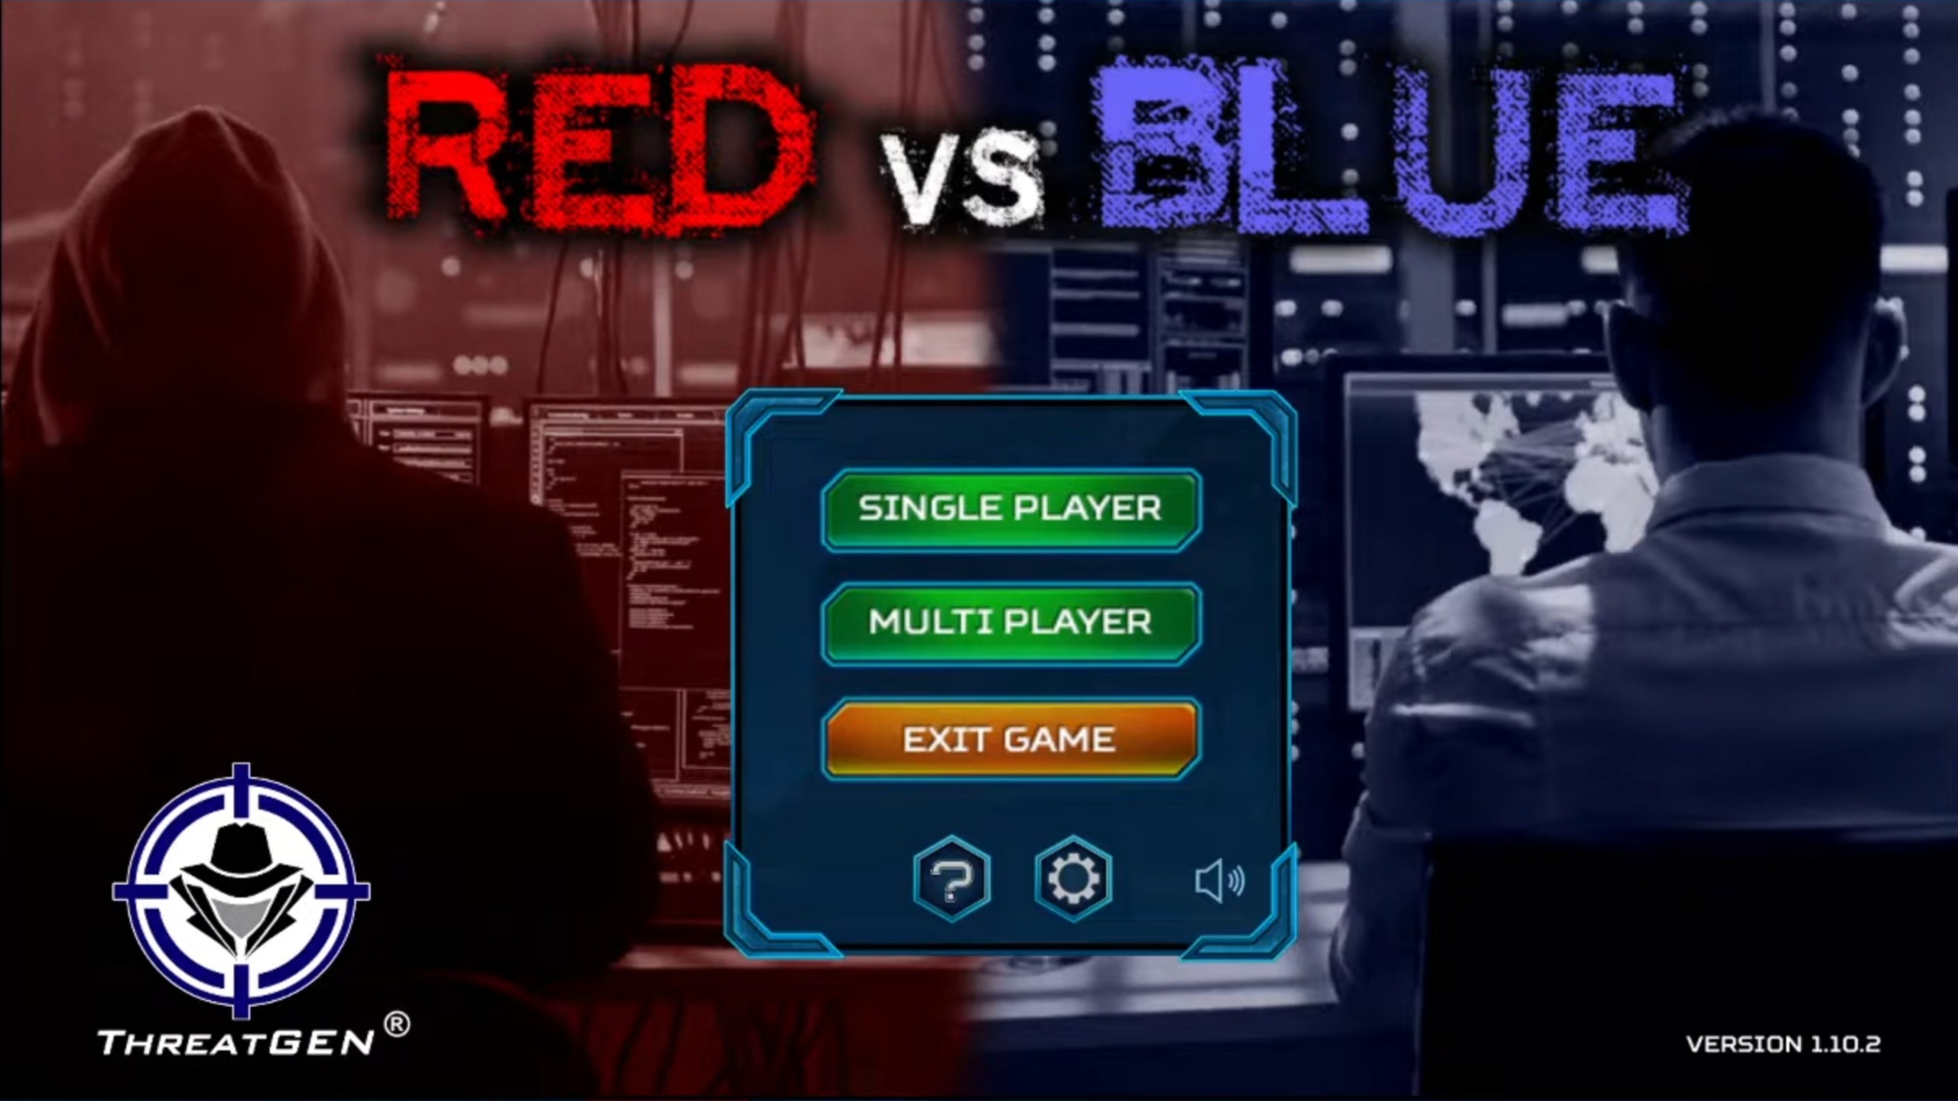

Figure 22 main menu

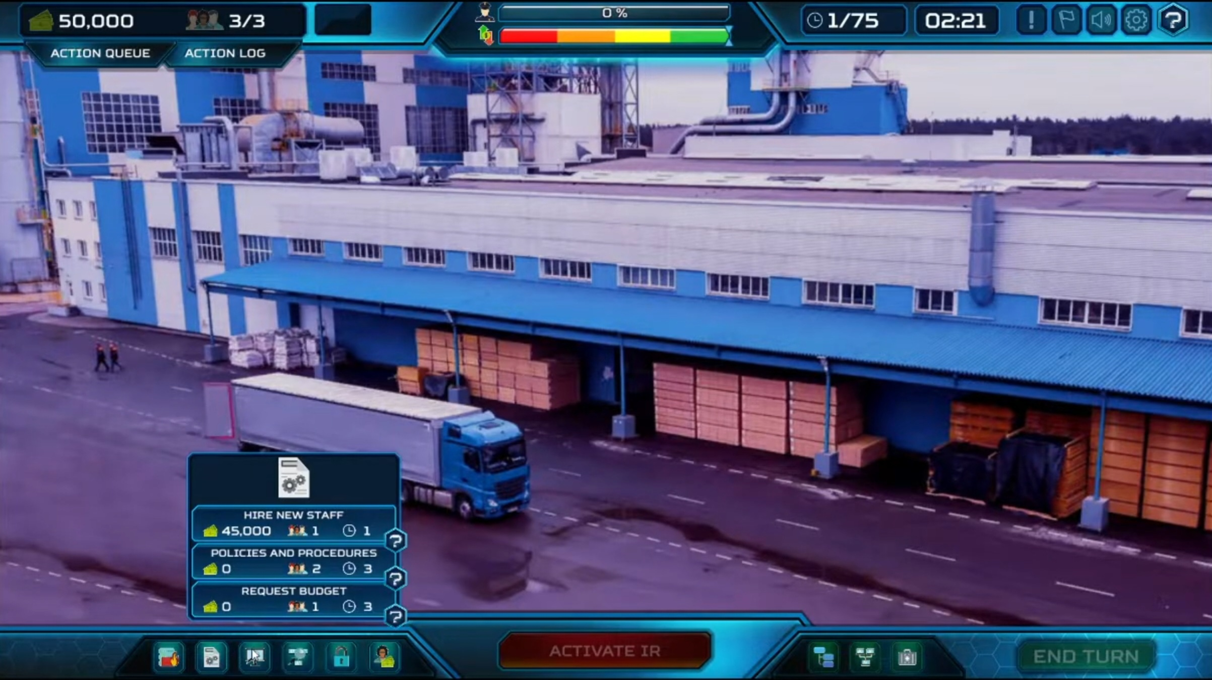

Figure 23 game category

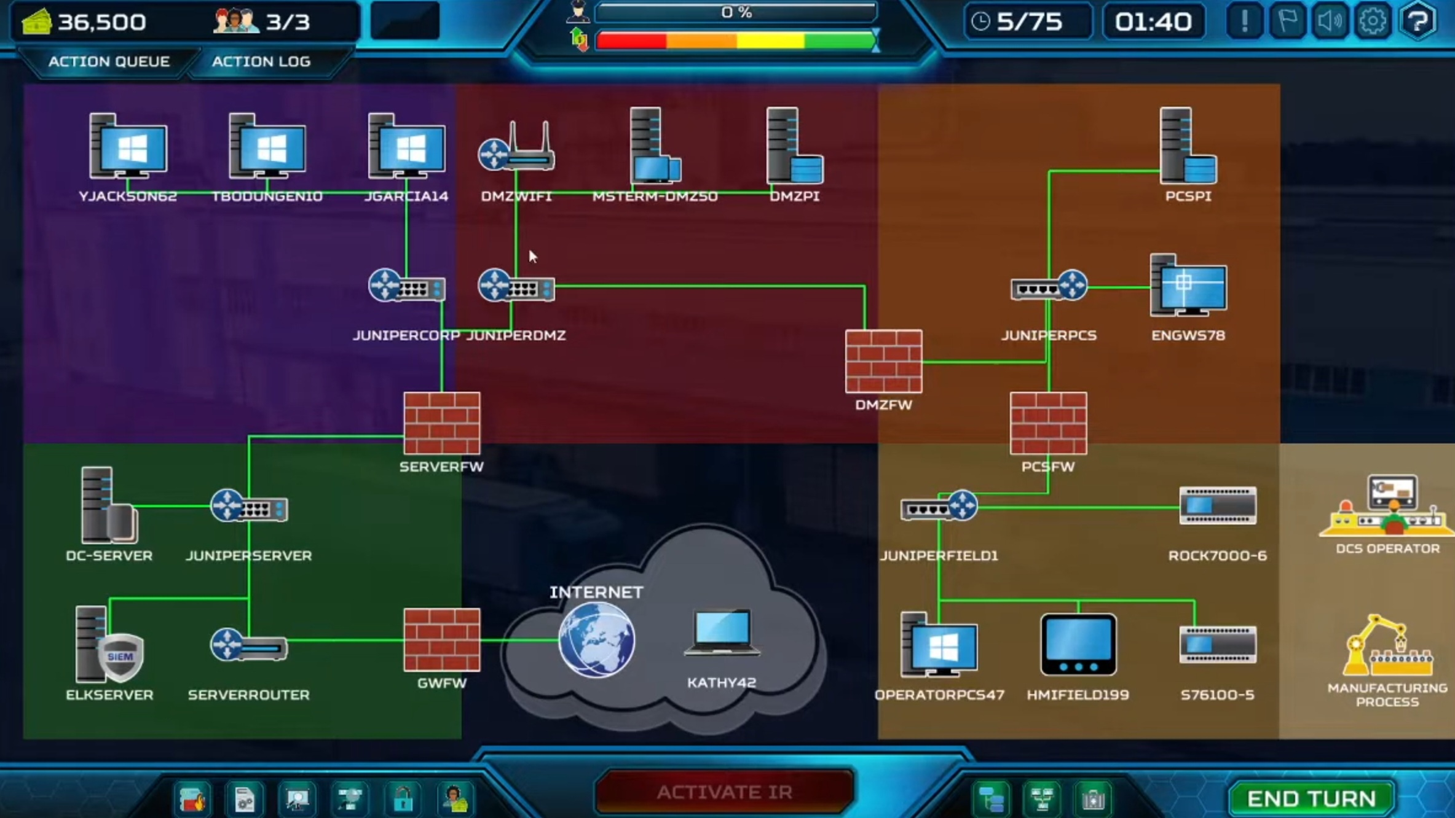

Figure 24 inside game

**2.1.9-Cyber attack Game**:

Introduction: The Cyber Attack Game is an immersive simulation platform that educates players on cybersecurity through realistic cyberattack scenarios.

A. Purpose:

The game target to provides a realistic experience of cyber attacks and aims to raise awareness and enhance cybersecurity understanding.

B. Gameplay Mechanics:

The game works by simulates various cyber attacks for players to defend against and requires critical decision-making and effective defense implementation.

C. Educational Value:

The values of the game are that it offers hands-on learning in cybersecurity and develops skills in threat detection, incident response, and risk management.

D. Impact on Understanding:

The game impacts improving understanding of cyber threats and defense strategies and promotes critical thinking and decision-making skills.

E. Practical Application:

The game affects the application by Bridges the gap between theoretical knowledge and practical application and encourages technical proficiency and problem-solving abilities.

Conclusion: The Cyber Attack Game is an educational tool that enhances understanding of cyber threats, fostering a cybersecurity mindset and preparing players for real-world cybersecurity challenges.

Some pictures:

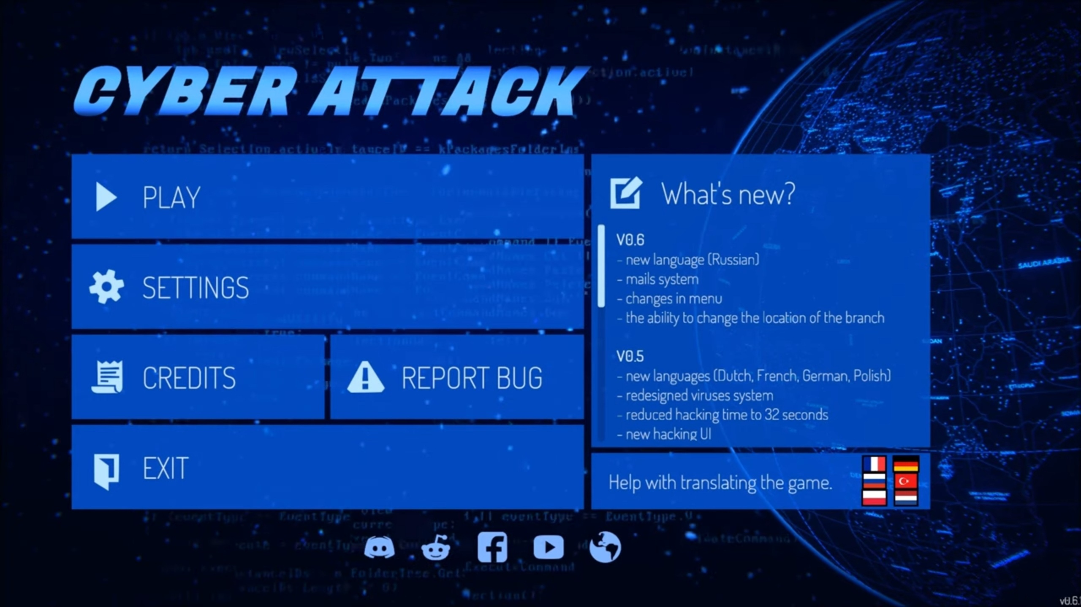

Figure 25 main menu

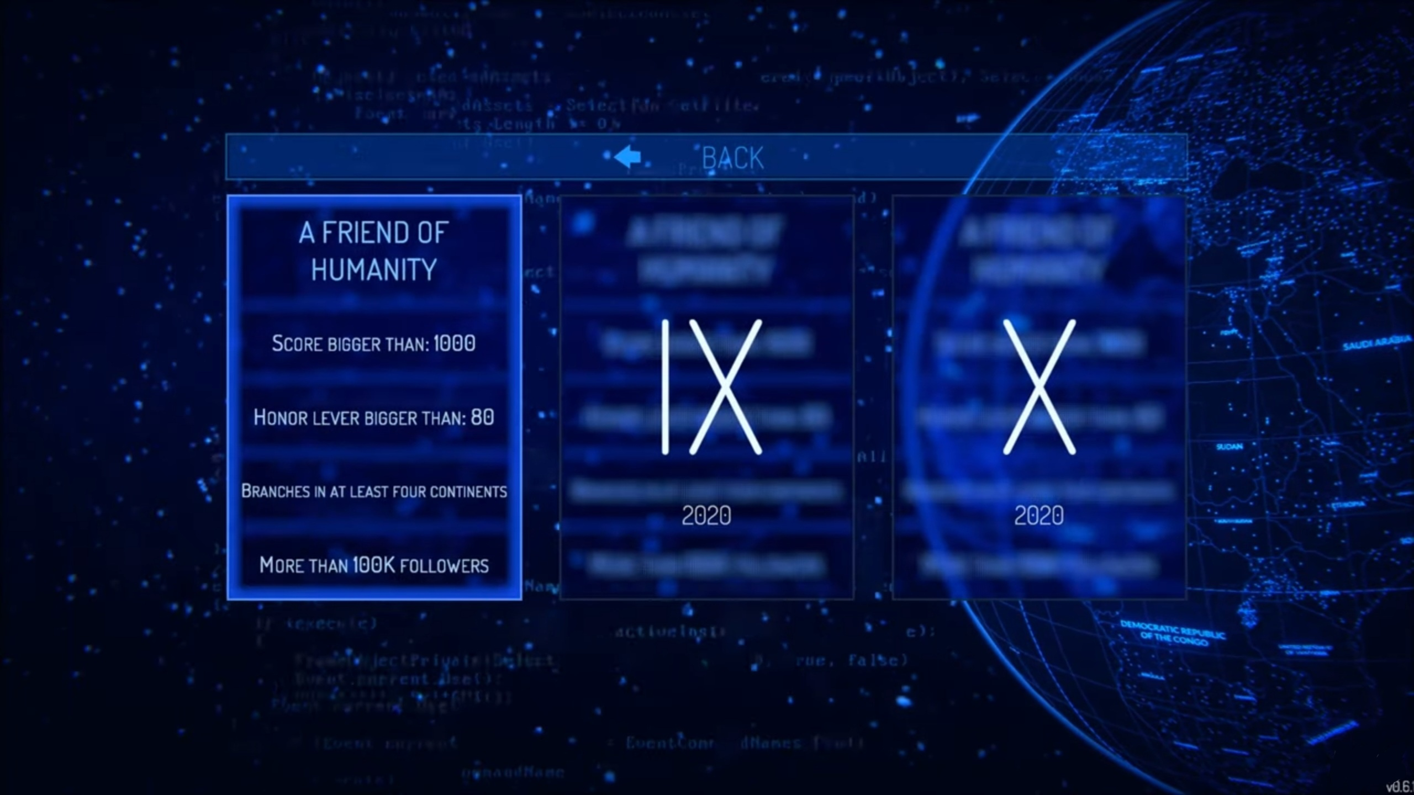

Figure 26 game category

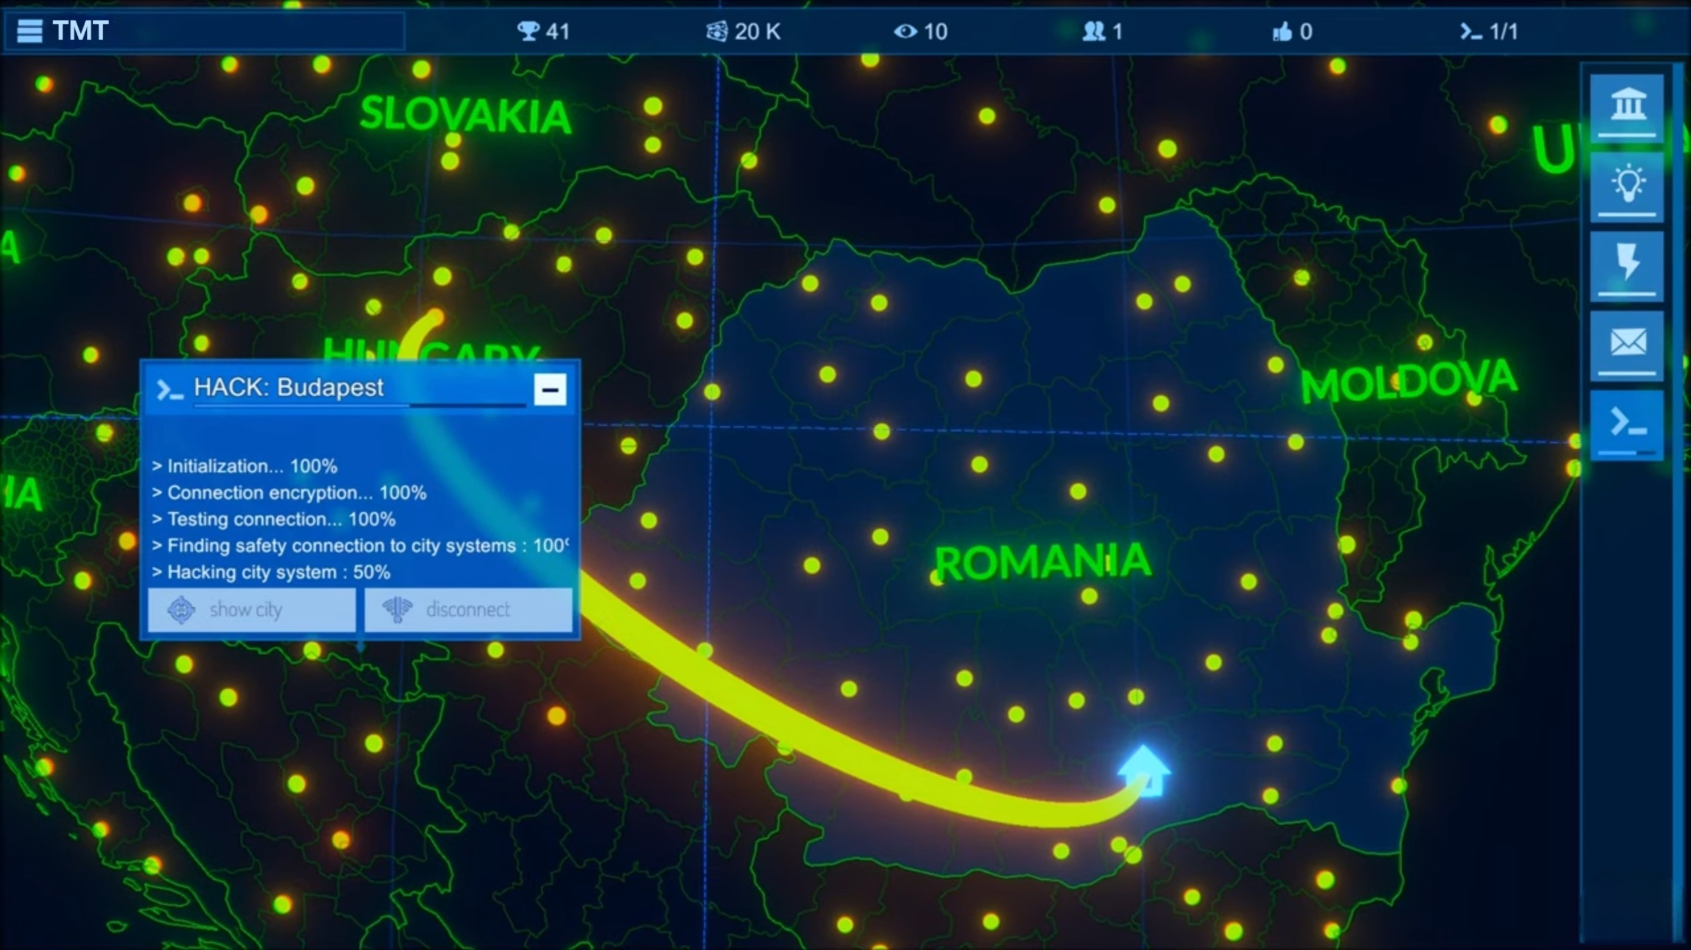

Figure 27 inside game

**2.1.10-Cyber ops**:

**Introduction**: Cyber Ops is a strategic video game that simulates the role of a cyber operations agent, focusing on defending against cyber threats.

A. Purpose:

The game targets to provides a realistic experience of a cyber operations agent and develops skills in threat detection, incident response, and decision-making.

B. Gameplay Mechanics:

The game works by combining stealth, tactical decision-making, and threat analysis and offers tools for players to simulate real-world cyber operations.

C. Educational Value:

The values of the game are hands-on learning in cybersecurity and promoting critical thinking, problem-solving, and teamwork.

D. Impact on Skills and Understanding:

The game impacts are enhances practical skills in threat analysis and risk management and provides a comprehensive understanding of the cyber threat landscape.

E. Career Development:

The game will encourage the exploration of cyber operations for career growth and exposes players to industry-standard tools, and encourages further education.

Conclusion: Cyber Ops is an immersive game that enhances cybersecurity skills and understanding, preparing players for real-world challenges and promoting career development in cybersecurity.

Some pictures:

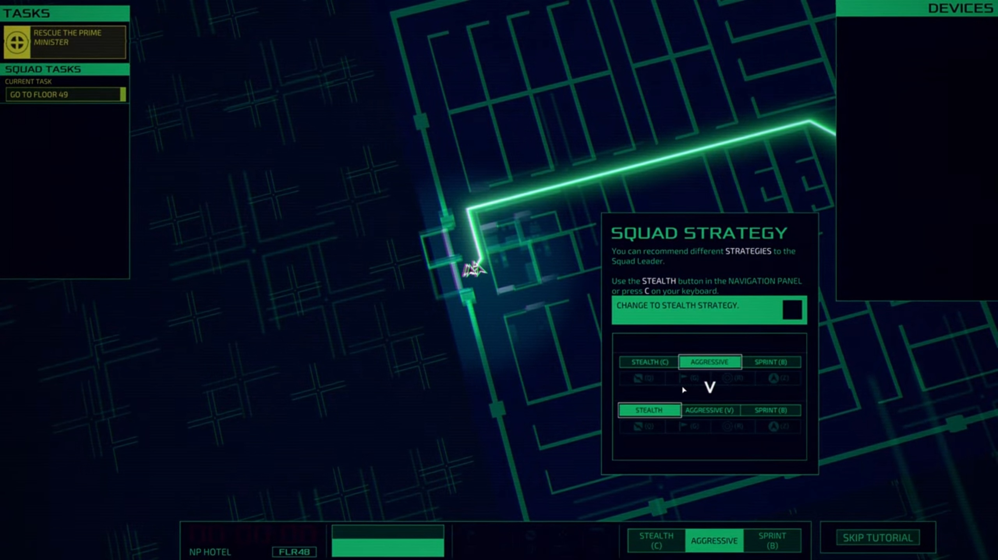

Figure 28 start of game

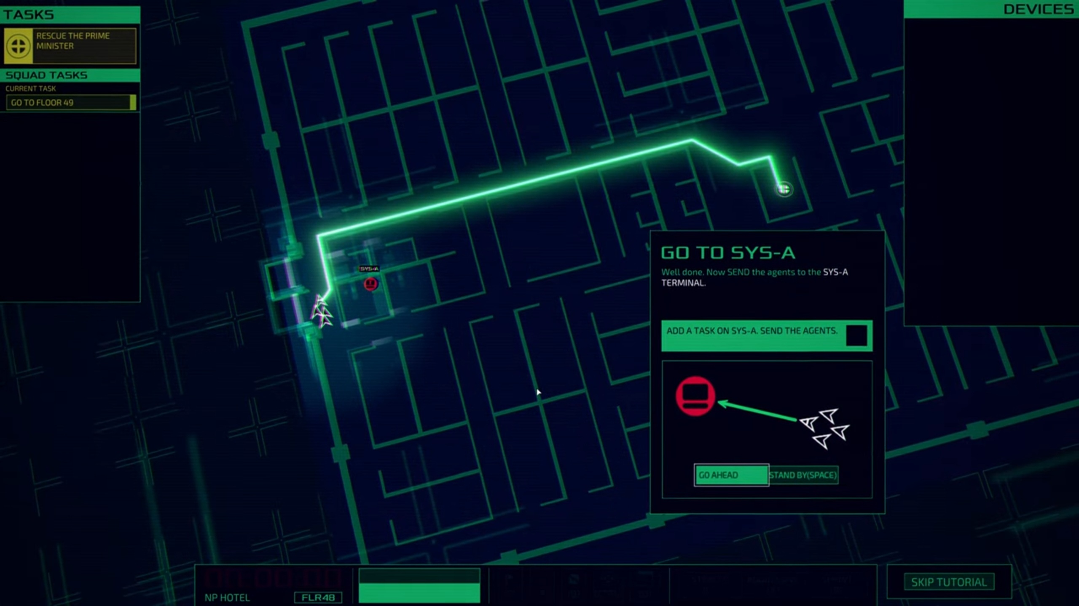

Figure 29 game tutorial

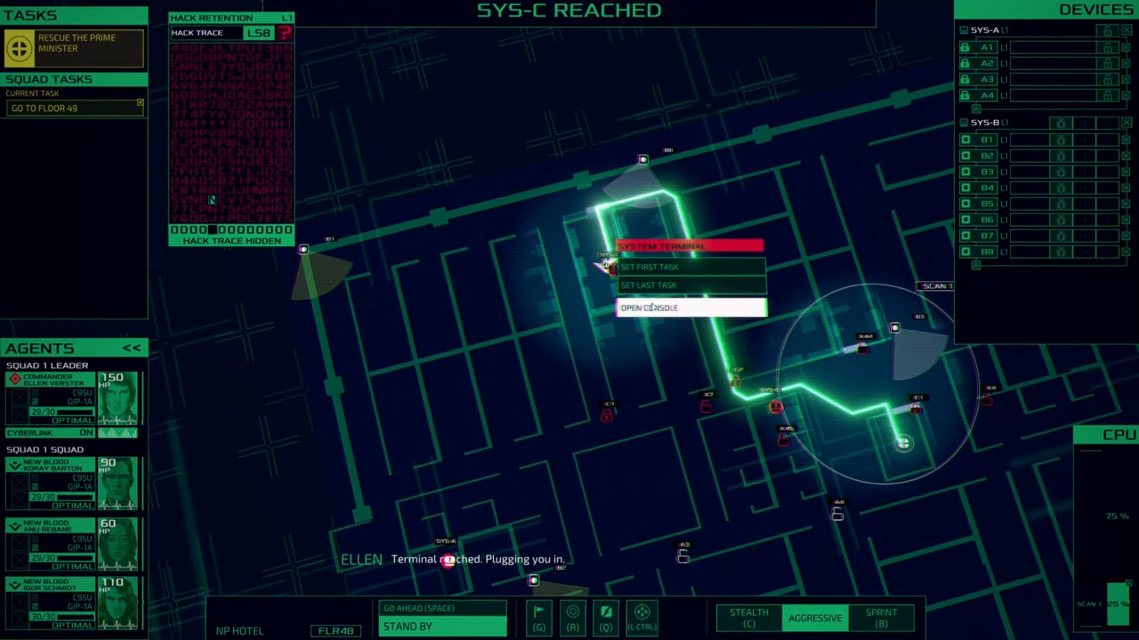

Figure 30 game challenge

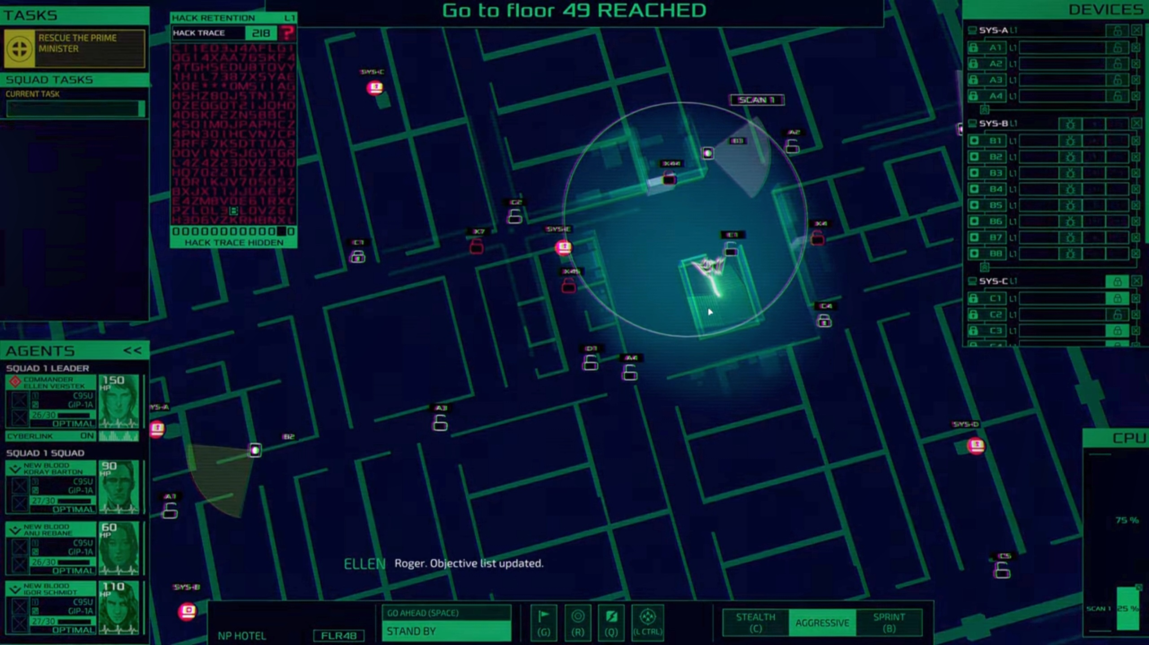

Figure 31 inside game

There are some courses we can take to educate about cybersecurity and there is some of them:

|  |  |  |  |
| --- | --- | --- | --- |
| Course Name | Platform | Topics | Price |
| Foundations of Cybersecurity | Google | Introduction to core concepts and building a knowledge foundation. Broad understanding of principles and skills in threat identification and security implementation. | Free (or low cost) |
| Ethical Hacking and Penetration Testing | Udemy | Focuses on ethical hacking techniques and practical skills in security flaw detection. Training in offensive security techniques and hands-on experience in ethical hacking. | Varies (typically around $10-$200) |
| Cyber Risk Management and Incident Response | SANS | Strategic focus on risk management and incident handling. Skills development in managing cybersecurity incidents and risk assessment. | High (usually $5,000-$7,000) |
| Cybersecurity Essentials | Cisco | Enhances professional credibility and validates cybersecurity knowledge. To foster a strong security mindset and proactive risk identification. | Varies (typically around $50-$300) |

Figure 32 courses about our game topics

**We can get educate about cybersecurity from videos and we searched for some Educational Cybersecurity video:**

“Cybersecurity Essentials: Protecting Your Digital Life” [1]

Focus: Individual benefits of cybersecurity.

Key Points: Importance of strong passwords, secure browsing, and staying informed.

“Cybersecurity 101: Protecting Your Business against Cyber Threats” [2]

Focus: Cybersecurity benefits for businesses.

Key Points: Data protection, financial loss prevention, customer trust, regulatory compliance.

“The Significance of Cybersecurity in Protecting Our Digital Frontier (5 Minutes)” [3]

Focus: Career opportunities in cybersecurity.

Key Points: Job security, competitive salaries, societal impact.

“Cybersecurity Resilience: The Key to Critical Infrastructure Protection” [4]

Focus: Cybersecurity in critical infrastructure.

Key Points: Consequences of cyber-attacks, the importance of robust cybersecurity measures.

“Fortify Your IoT Security: Key Solutions to Protect Your Connected World |Algoworks” [5]

Focus: Cybersecurity challenges and benefits in IoT.

Key Points: Privacy maintenance, unauthorized access prevention, system integrity.

|  |  |  |  |
| --- | --- | --- | --- |
| Platform | Topic | Number of videos talking about same topic | Year |
| YouTube | Cybersecurity Essentials: Protecting Your Digital Life | 27700 | Dec 22, 2023 |
| YouTube | Cybersecurity 101: Protecting Your Business against Cyber Threats | 34700 | Jul 19, 2023 |
| YouTube | The Significance of Cybersecurity in Protecting Our Digital Frontier (5 Minutes) | 1530 | Sep 27, 2023 |
| YouTube | Cybersecurity Resilience: The Key to Critical Infrastructure Protection | 8410 | Dec 18, 2023 |
| YouTube | Fortify Your IoT Security: Key Solutions to Protect Your Connected World | 578 | Sep 12, 2023 |

Figure 33 videos about our game topics

**The videos about cybersecurity:** These videos offer diverse information about cybersecurity importance across different sectors and for various audiences but it can't test your understanding about the subject.

**The courses about cybersecurity:** we can get more detailed information about cybersecurity skills and we will get benefits with its certification in our jobs or getting new jobs but it is boring for beginner students who will learn about cybersecurity.

**Educational Video Games and Adaptability:** A study by Ninaus et al. discusses the role of analytics for adaptivity within educational video games [6]. The research highlights that serious games and digital game-based learning can be effective educational tools. However, the effectiveness is influenced by several factors, including the adaptivity of the game to the individual needs of the learner, the learning material, and environmental factors. The field is relatively young, and there is a need for strong theoretical foundations and standardized reporting across disciplines.

**Gamification in Education:** Another relevant study by Manzano-León et al. reviews the impact of gamification in education [7]. This study examines the evidence on how gamification affects student motivation and academic performance. It suggests that gamification, which includes the use of game elements in educational settings, can potentially improve academic performance, engagement, and motivation of students.

In summary, the principles of adaptivity in educational games, the impact of gamification on learning, and the planning of space based on user behavior are all relevant topics that can inform the development and analysis of such games.

These studies suggest a growing interest in adaptive educational games and the potential benefits they can offer in terms of learning outcomes and user engagement.

**2.2 Our Game:**

From previous research we have learned some main idea we can summarize it to a few main topics :

Educational Value:

Cybersecurity games are valuable educational tools that teach key concepts and skills through hands-on experience and problem-solving.

Skill Development:

These games enhance skills like resource management, strategic planning, and decision-making, applicable in real-world cybersecurity.

Engagement and Immersion:

Immersive gameplay, graphics, and sound design engage players, creating emotional connections and a sense of accomplishment.

Real-World Relevance:

Games bridge the gap between theory and practice by simulating realistic cyber attack scenarios, preparing players for actual cybersecurity challenges.

Integration into Education and Training:

Cybersecurity games can be part of educational curricula and training programs, offering adaptive and customizable learning experiences.

Collaboration and Community:

They promote collaboration and community engagement, with players sharing strategies and mods, enhancing the games’ longevity and personalization.

Potential Technological Advancements:

Future cybersecurity games may include VR/AR for more immersive experiences and AI for improved gameplay dynamics.

Conclusion: Cybersecurity games are interactive platforms that not only educate about online safety and digital behavior but also encourage creativity and professional growth in cybersecurity.

Our game focuses on:

Simplicity: the game will be simpler to be suitable for beginners.

Comprehensive Curriculum: Covers network security, cryptography, ethical hacking, incident response, and secure coding.

Adaptive Learning: Personalizes learning experiences based on individual skill levels and progress.

Collaborative Features: Includes team-based activities and virtual competitions.

Existing Games:

Cyber Adventure:

Focuses on adventure and narrative-driven gameplay.

Provides a basic introduction to cybersecurity concepts.

Space Shelter:

Offers survival-based gameplay in a cyber-themed environment.

Introduces cybersecurity concepts within the gameplay.

Interland:

Teaches internet safety and digital citizenship for children.

Designed for younger audiences with a focus on online behavior.

Cybersecurity Lab:

Provides virtual lab environments for hands-on cybersecurity experimentation.

Offers interactive simulations but may lack a comprehensive curriculum.

Other Games (Keep Tradition Secure, Defend the Crown, Network Collapse, ThreatGEN: Red vs. Blue, Cyber Attack Game, Cyber Ops):

Focus on specific scenarios like defense strategies and team-based cyber operations.

Target cybersecurity professionals or those interested in specific domains.

Conclusion: our game stands out by offering a structured learning experience that is adaptable and suitable for beginner learners, setting it apart from existing games that often focus on specific aspects or audiences and it has difficulties making it playable as well as educational. Our game aims to provide an all-encompassing approach to cybersecurity education through a blend of theory, practical application, and collaborative learning and it will take their simplicity from Interland and defend the Crown and network collapse and their deep information from ThreatGEN: Red vs. Blue.

|  |  |  |  |  |  |  |
| --- | --- | --- | --- | --- | --- | --- |
| Game | Focus | Target Audience | Educational Value | Gameplay Mechanics | Real-World Application | Released Date |
| Cyber Adventure | Adventure & narrative-driven | General | Basic cybersecurity concepts | Puzzles and challenges | Limited | 19 April 2022 |
| Space Shelter | Survival in a cyber-themed environment | General | Introduction to cybersecurity | Survival mechanics | Limited | 13 October 2021 |
| Interland | Internet safety & digital citizenship | Children & young teens | Online behavior & safety | Interactive, child-friendly | High | 6 June 2017 |
| Cybersecurity Lab | Hands-on cybersecurity experimentation | Students & beginners | Cybersecurity principles &practices | Virtual lab simulations | Moderate | 28 October 2019 |
| Keep Tradition Secure | Cultural Heritage & cybersecurity | General | Awareness of cybersecurity in cultural heritage | Scenario-based challenges | Moderate | 20 October 2017 |
| Defend the Crown | Strategic decision-making & tower defense | General | Strategic thinking & problem-solving | Defense strategy planning | Moderate | 16 June 2021 |
| Network Collapse | Network troubleshooting & management | Aspiring professionals | Network architecture & security | Simulated network collapse scenarios | High | 15 December 2021 |
| ThreatGEN: Red vs. Blue | Offensive & defensive cyber operations | Cybersecurity professionals | Red team vs blue team tactics | Team-based cyber operations | High | 4 September 2019 |
| Cyber attack Game | Cyber attacks & defense strategies | General | Threat detection & risk management | Simulated attack scenarios | High | 20 August 2020 |
| Cyber ops | Cyber operations & defense | Aspiring professionals | Cyber threat analysis & incident response | Strategic & tactical decision-making | High | 21 May 2020 |
| Our game | Cyber attacks & defense strategies | General | Cybersecurity principles &practices | Simulated attack scenarios | Moderate | Soon |

We asked 20 people four questions and make surveys charts about our game target:

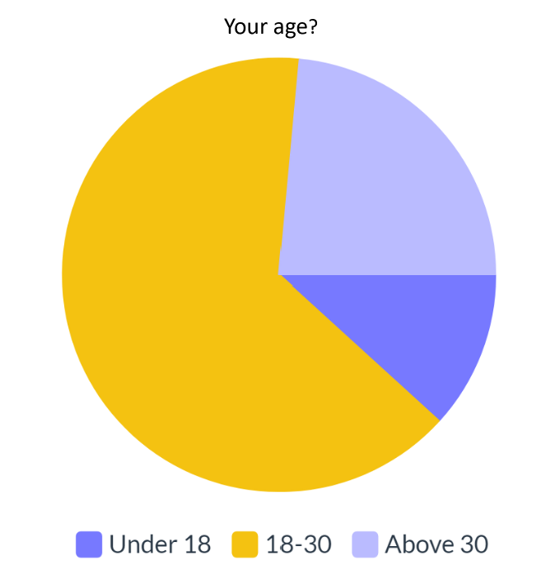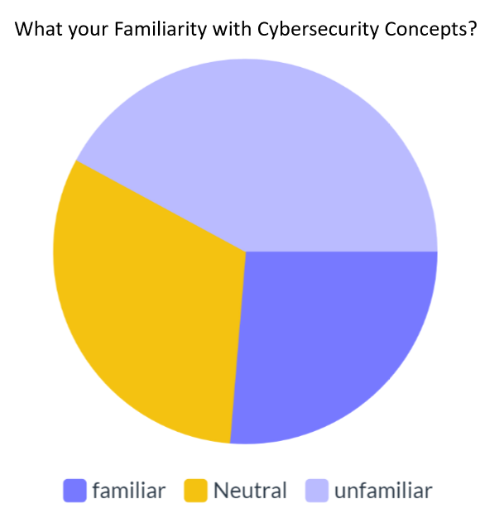

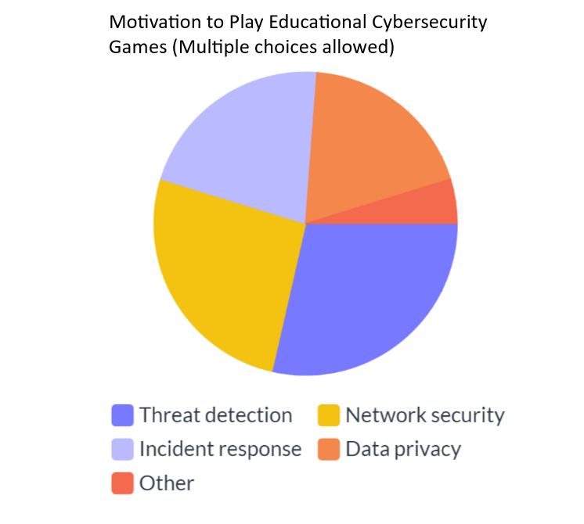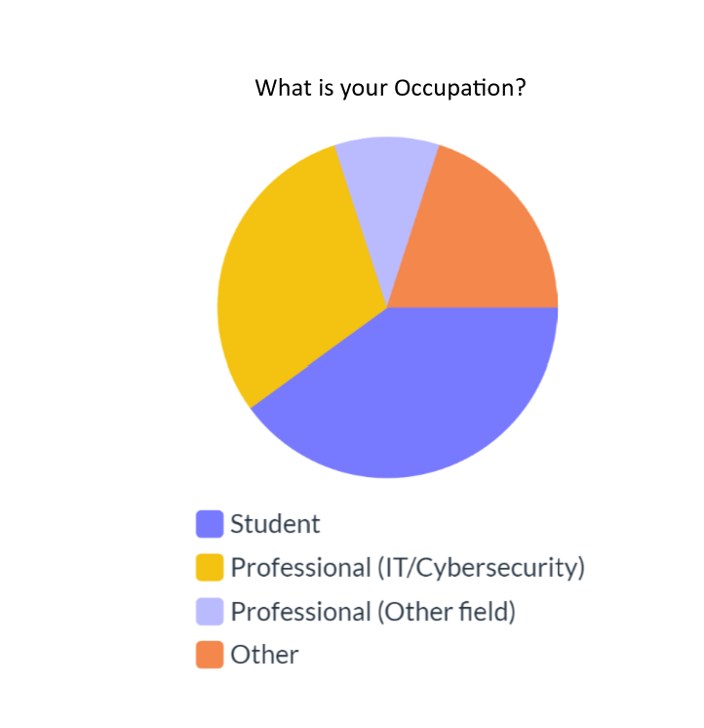

**CHAPTER 3**

**SYSTEM ANALYSIS AND DESIGN**

**3.1 Introduction**

The system analysis and design of a cybersecurity educational game involves understanding user requirements, designing an intuitive interface, and integrating educational content to create an engaging platform for individuals to learn and enhance their cybersecurity skills and knowledge.

**3.2 user characteristics**

The cybersecurity educational game targets a wide range of users, including individuals of varying ages and backgrounds.

The users will be within the age range from 8 years and older. They may have limited knowledge of cybersecurity concepts but possess a high level of curiosity and interest in technology. The game should employ age-appropriate language, visuals, and gameplay to engage and educate this demographic effectively. These users they have little to no prior knowledge of cybersecurity concepts and terminology. They require a game that starts with foundational concepts and gradually progresses to more advanced topics, ensuring an accessible learning experience.

**3.3 Functional Requirements**

1. Register Account: The user can create accounts to track their progress, achievements, and scores.

2. Log-in: The user can access their account where their progress, achievements and scores are stored.

3. View Tutorial: Detailed guidance is provided to help the user understand the game mechanics, controls, and cybersecurity concepts.

4. Pick Level: The user faces increasing difficulty levels and challenges covering various cybersecurity topics.

5. Access Educational Resources: The User has access to a wide range of subjects, including encryption, secure coding, social engineering, data privacy, and network protocols, are covered.

6. Receive Feedback: The user receives immediate feedback and explanations to understand correct cybersecurity practices.

7. Track Progress: The user can see progress, completed levels, achievements, and scores are tracked with visible indicators for motivation.

8. View Hint: Challenging sections can be aided with hints to guide the user through the game.

9. Score Points: The user receives points depending on their performance at each level.

10. Save Progress: Users can save their progress and resume the game at their convenience.

**3.4 Non-Functional Requirements:**

1. Performance: It should run smoothly and load quickly, handling multiple users without slowdowns.

2. Scalability: It should accommodate a growing user base without requiring major infrastructure changes.

3. Security: User data should be securely stored, sensitive information encrypted, and protection against cyber threats in place.

4. Compatibility: The game should work on different devices and adapt to various screen sizes and resolutions.

5. Accessibility: It should be accessible to different kinds of users, following accessibility standards.

6. User Interface and User Experience: The interface should be intuitive, user-friendly, visually appealing, and engaging.

7. Reliability: The game should be reliable, minimizing crashes and errors, and providing helpful error messages.

8. Maintainability: The code should be well-organized, allowing for future updates and bug fixes.

9. Localization and Internationalization: It should support multiple languages and adapt to different users.

10. Data Privacy: The game should comply with data privacy regulations, gain user consent, and communicate data usage and protection.

11. Backup and Recovery: Regular data backups and disaster recovery procedures should be in place.

12. Documentation: Comprehensive documentation for users and developers should be provided.

**3.5 Software Requirements**

To build the system we need the following software:

- Unreal Engine 5, developed by Epic Games, is a cutting-edge game engine that pushes visual fidelity and interactive storytelling with features like Nanite for detailed environments and Lumen for dynamic lighting. The engine also includes the MetaHuman Creator for realistic digital humans, providing developers with the tools to create next-generation games and experiences. We chose it because it is letting us developing by blueprints instead of coding and it has store contains a lot of free subject.

-blender, Blender is a free 3D software that lets us create dynamic and animated content, from characters to entire worlds. It's versatile, used in everything from scientific simulations to movie special effects. Perfect for developing a cyber security game, Blender allows us to design characters, environments, and assets, and bring cyber threats to life with thrilling animations.

- 3ds max, powerful software tool for creating 3D models, animations, and visual effects. It's perfect for developing immersive environments and realistic scenarios for a cyber security game. With its versatile features, we can design everything from characters to landscapes with intricate details. Its animation and interactivity tools make it easy to bring our game world to life.

-MySQL, free program uses for saving data and hosting service for our game what we can develop it by unreal engine 5 and connect it with database

**3.6 Hardware requirements**

To build the system we need Personal Computer with the following configuration:

- At least 8 GB RAM (Random Access Memory), this will allow for faster loading of the testing platforms.

- Quad-core Intel 2.5 GHZ (Giga Hertz) processor speed During the testing phase of the codes written, this will facilitate faster processing of the requests by the application as well as speed up responses for the earlier given requests.

- At least 80GB hard disk capacity this is to provide the storage space for the game’s workspace where the various codes that will be written will reside.

- Internet connection to be able to get the updates and services we need a stable internet connection.

- Graphics card unit (gpu) have at least 8GB of VRAM to load different 3d models and textures.

**3.7 Use-case Diagram:**

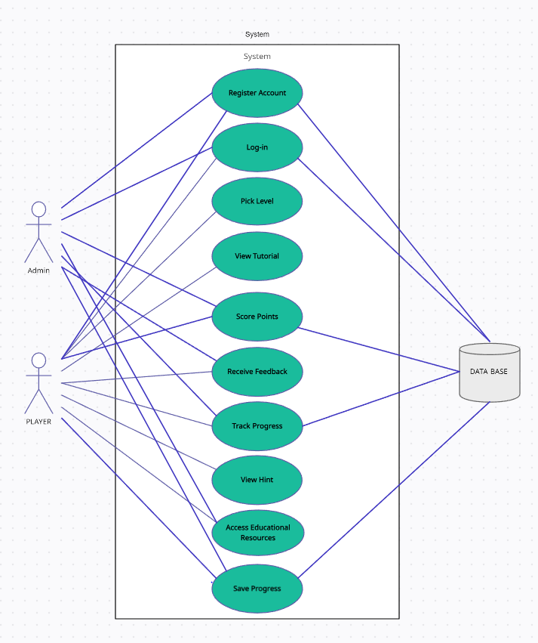

Figure 34: Use-case Diagram

**3.8 use-case description:**

Table 1 account register use case description

|  |  |
| --- | --- |
| Use case | Register Account |
| Actors | Player, admin |
| Description | The player creates a new account to track their progress, achievements, and personalized data within the game |
| Data entered | Name, email, password, character ID |
| Stimulus | Clicking on register button and fill the form |
| Response | verifies information and save account information on database |
| Comments | if player email already exist a massage will be displayed |

Table 2 Login use case description

|  |  |
| --- | --- |
| Use case | Login |
| Actors | Player, admin |
| Description | The player logs into their existing account to access their saved progress, scores, and other personalized data |
| Data entered | character ID or email, password |
| Stimulus | Clicking on login button and fill the form |
| Response | validate character ID/email and password and then allow access to the game |
| Comments | If character ID / password is not correct system display error massage, and they must have an account |

Table 3 Pick level use case description

|  |  |
| --- | --- |
| Use case | Pick level |
| Actors | Player |
| Description | The player selects a specific level or challenge from the game's available options and engages in gameplay to complete the selected level using their knowledge of cybersecurity concepts. |
| Data entered | ------ |
| Stimulus | Clicking on level button |
| Response | Takes the player to level that he clicked on |
| Comments | if player didn’t reach the level exist a notification will be displayed |

Table 4 view tutorial use case description

|  |  |
| --- | --- |
| Use case | View tutorial |
| Actors | Player |
| Description | The player accesses the tutorial or instruction section of the game to learn about the game mechanics, controls, and cybersecurity concepts. |
| Data entered | ---- |
| Stimulus | Clicking on tutorial button |
| Response | show tutorial how to play the game |
| Comments | ---- |

Table 5 Receive feedback use case description

|  |  |
| --- | --- |
| Use case | Receive feedback |
| Actors | Player, admin |
| Description | The player receives feedback on their actions, answers, or performance within the game, providing guidance and assessment of their progress and understanding of cybersecurity concepts. |
| Data entered | Feedback text |
| Stimulus | Clicking on feedback button and fill the form |
| Response | verifies information and save feedback information on database |
| Comments | if player didn’t enter text exist a massage will be displayed |

Table 6 Track progress use case description

|  |  |
| --- | --- |
| Use case | Track progress |
| Actors | Player, admin |
| Description | The player monitors and tracks their progress, achievements, scores, and level completion status throughout the game, allowing them to gauge their overall performance and identify areas for improvement. |
| Data entered | Track level |
| Stimulus | Clicking on track progress button |
| Response | show information and save it on database |
| Comments | if player didn’t do any progress exist a massage will be displayed |

Table 7 view hint use case description

|  |  |
| --- | --- |
| Use case | View hint |
| Actors | Player |
| Description | The player utilizes the hint system provided by the game to receive assistance, tips, or hints when facing challenging levels or tasks, helping them overcome obstacles and enhance their learning experience. |
| Data entered | ----- |
| Stimulus | Clicking on hint button |
| Response | Show hint information |
| Comments | if player show hint already exist a massage will be displayed |

Table 8 Access educational resources use case description

|  |  |
| --- | --- |
| Use case | Access educational resources |
| Actors | Player, admin |
| Description | The player accesses additional educational resources such as articles, videos, or external references related to cybersecurity, providing supplemental information and expanding their knowledge beyond the game's content. |
| Data entered | ----- |
| Stimulus | Clicking on educational resources button |
| Response | Take player to education resources about his level topic |
| Comments | ---- |

Table 9 save progress use case description

|  |  |
| --- | --- |
| Use case | Save progress |
| Actors | Player, admin |
| Description | The player saves their current progress within the game, allowing them to resume from the same point later on and retain their achievements, scores, and unlocked content. |
| Data entered | Player progress |
| Stimulus | Clicking on save button |
| Response | verifies information and save progress information on database |
| Comments | if player saved progress already exist a massage will be displayed |

Table 10 Score points use case description

|  |  |
| --- | --- |
| Use case | Score points |
| Actors | Player, admin |
| Description | The player receive point reflecting his performance at each level which is added to his overall points in all levels and saved in the database. |
| Data entered | Player score |
| Stimulus | Finishing the level |
| Response | Calculate the score and it to the overall and save it in the database |
| Comments | ---- |

**3.9 interaction diagrams:**

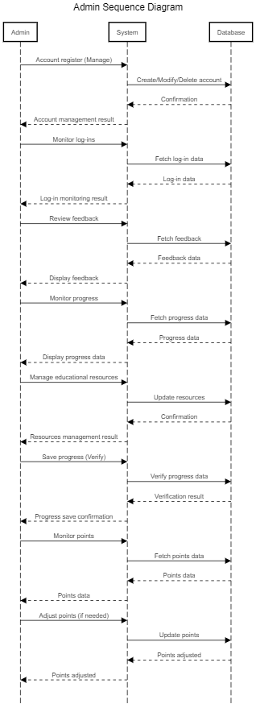

Figure 35 sequence diagram for admin

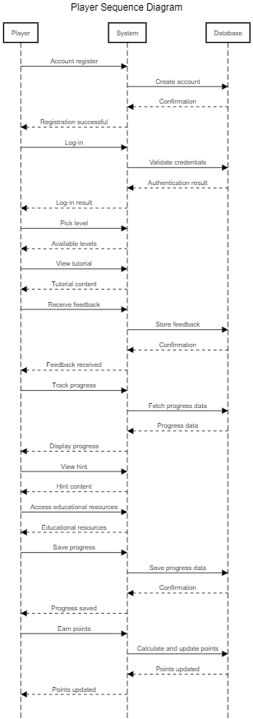

Figure 36 sequence diagram for player

**3.10 flow chart:**

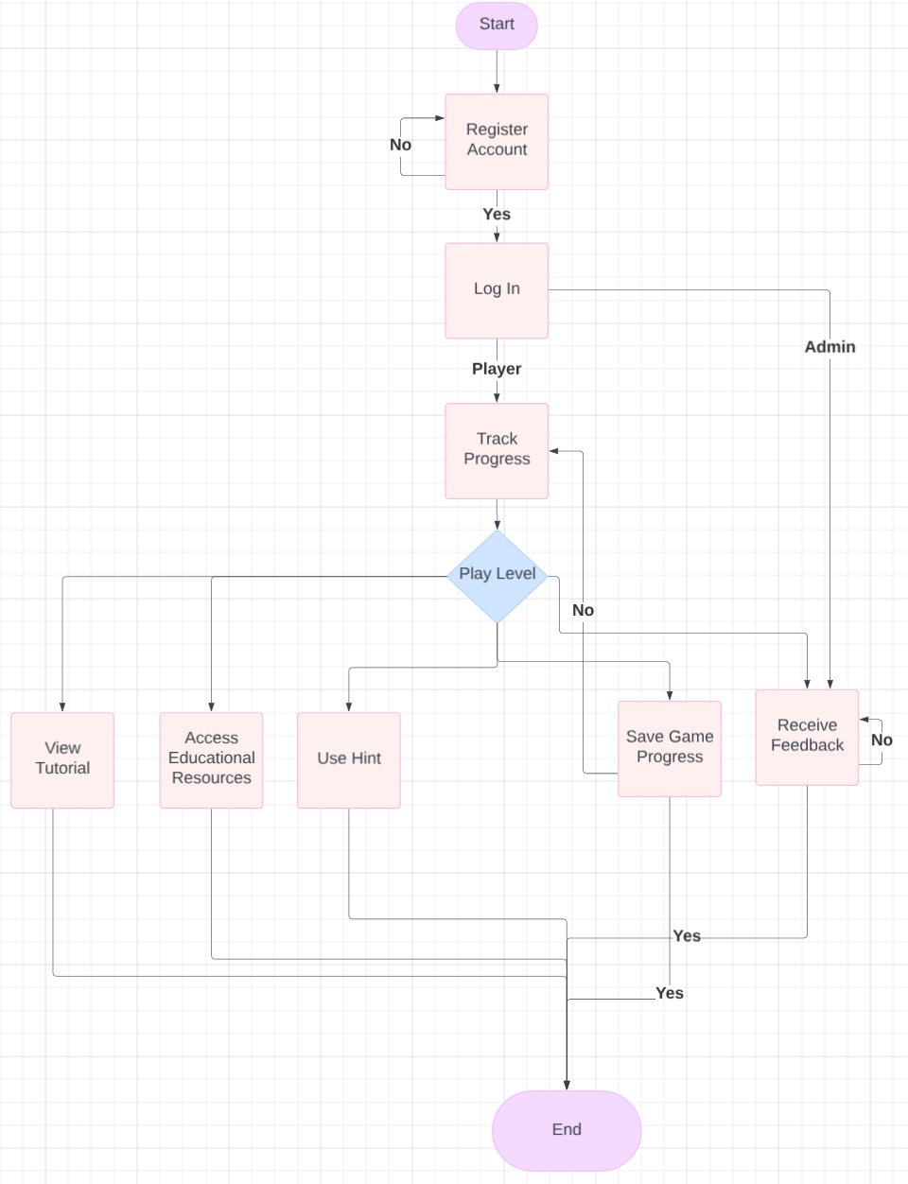

Figure 37 flow chart of our game

**3.11 Class Diagram:**

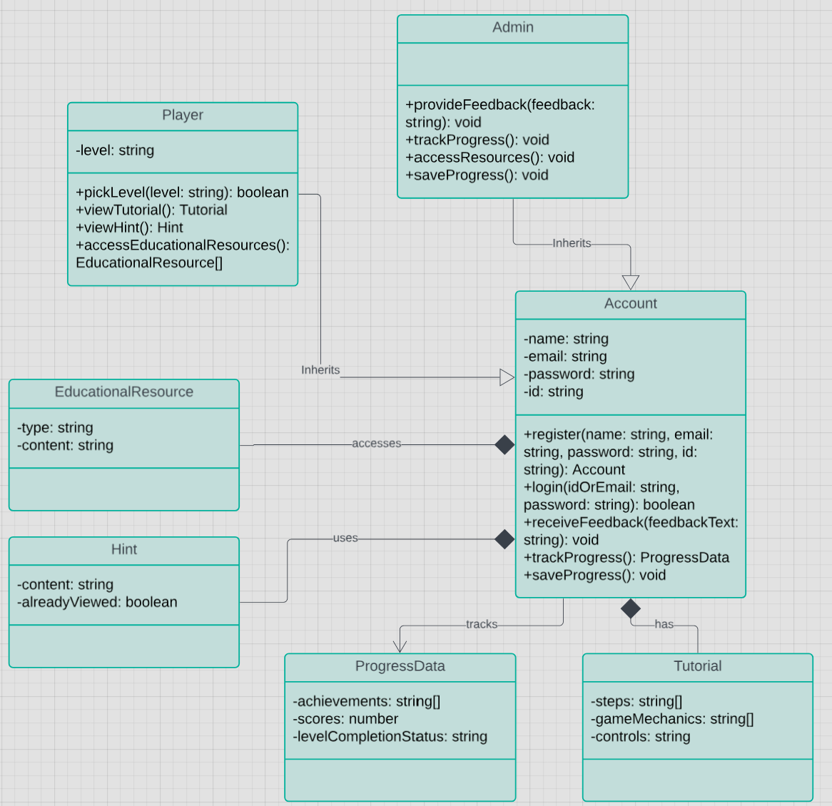

Figure 38 class diagram of our game

**3.12 Database Design:**

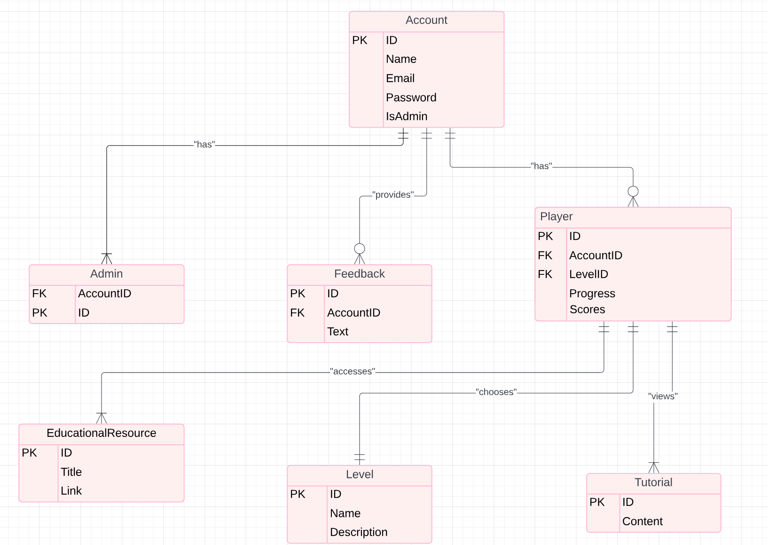

Figure 39 database design of our game

**3.13 ERD Diagram:**

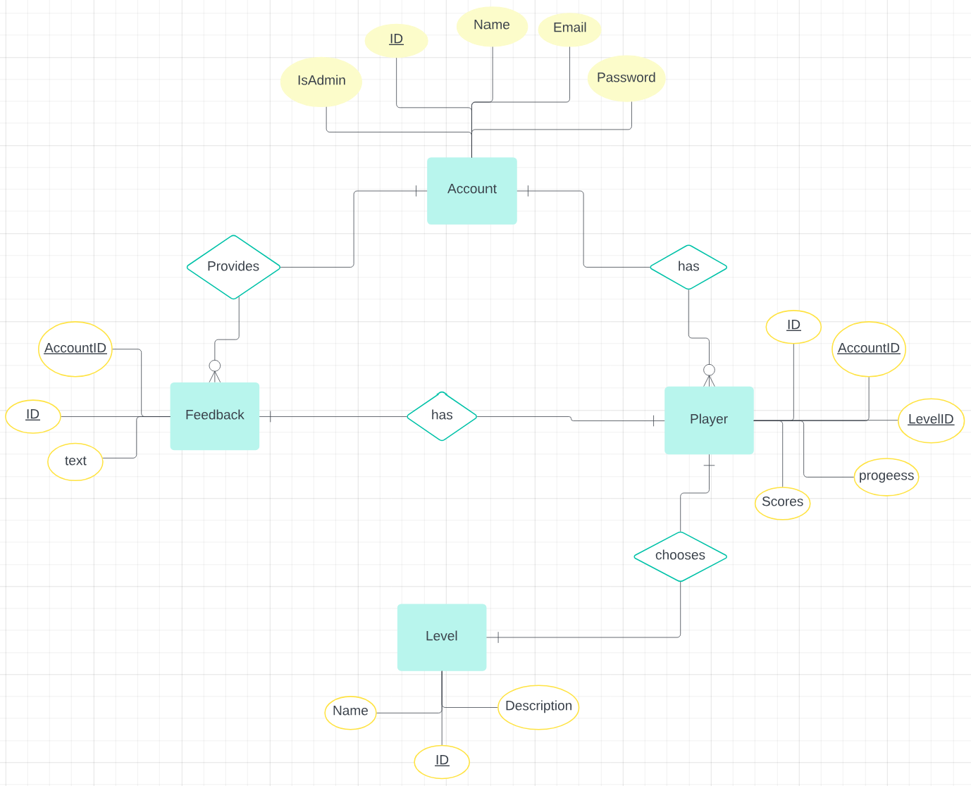

Figure 40 ERD diagram

**3.14 Database Schema :**

**Account**

|  |  |  |  |  |
| --- | --- | --- | --- | --- |
| Id | name | email | Password | isAdmin |

**Admin**

|  |  |
| --- | --- |
| AccountId (FK) | Id |

**Player**

|  |  |  |  |  |
| --- | --- | --- | --- | --- |
| Id | AccountId (FK) | Progress | Scores | levelId (FK) |

**Feedback**

|  |  |  |
| --- | --- | --- |
| Id | AccountId (FK) | text |

**EducationalResource**

|  |  |  |
| --- | --- | --- |
| Id | Title | Link |

**Level**

|  |  |  |
| --- | --- | --- |
| Id | Name | Description |

**Tutorial**

|  |  |
| --- | --- |
| Id | Content |

**3.15 prototype:**

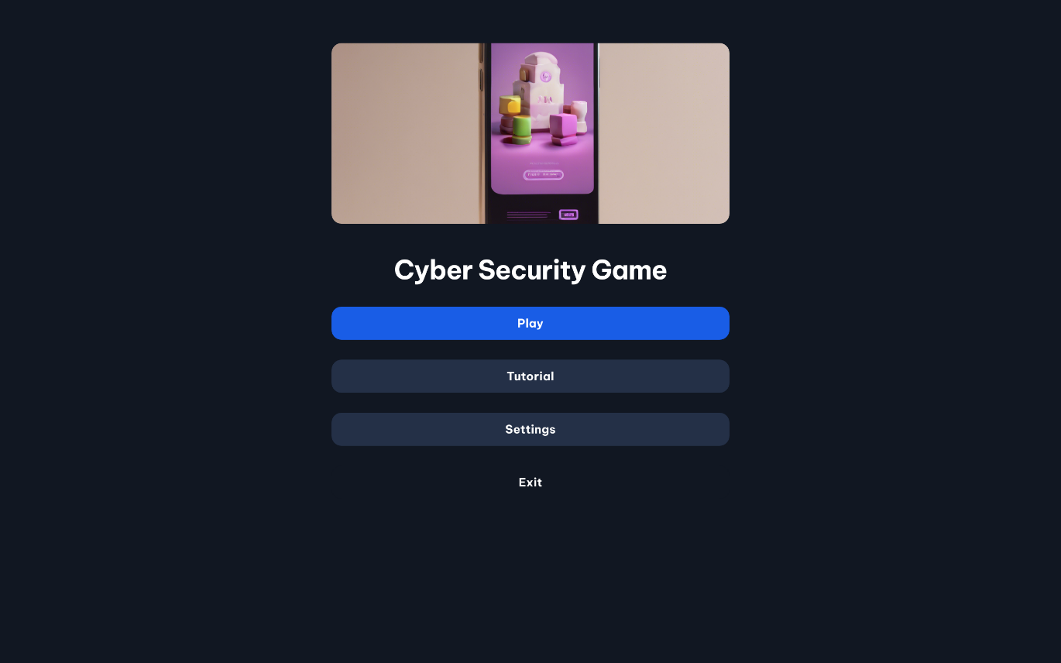

Figure 41 main menu

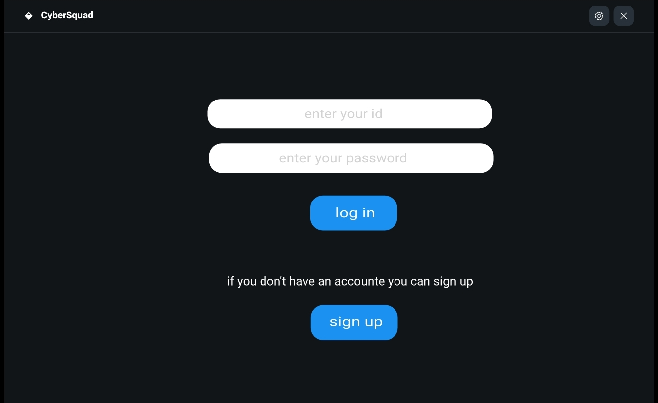

Figure 42 log in

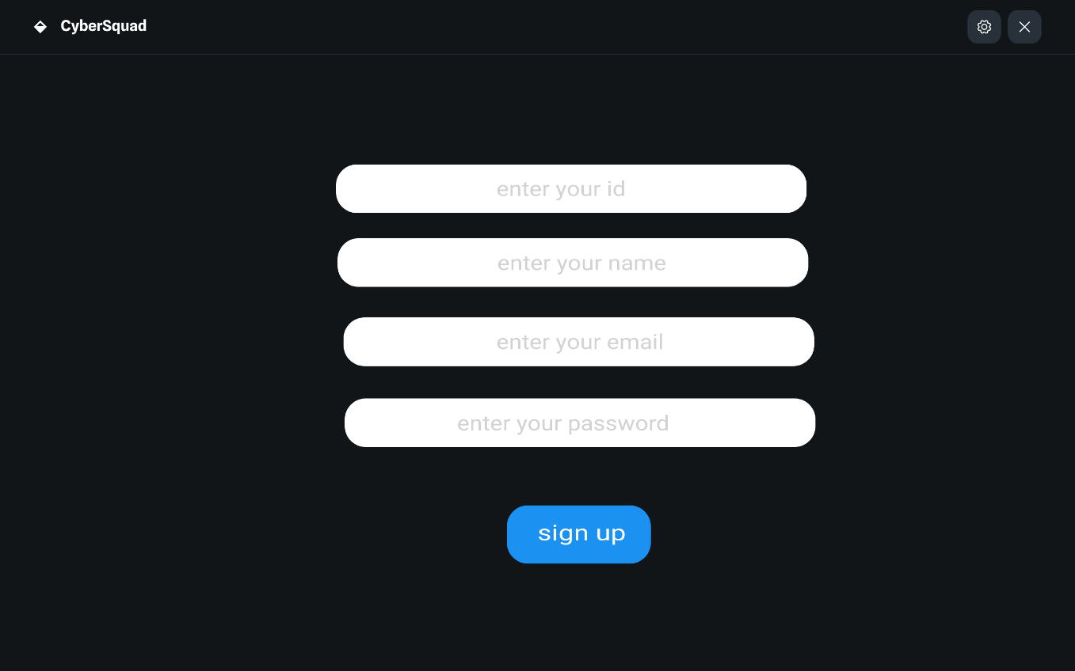

Figure 43 sign up

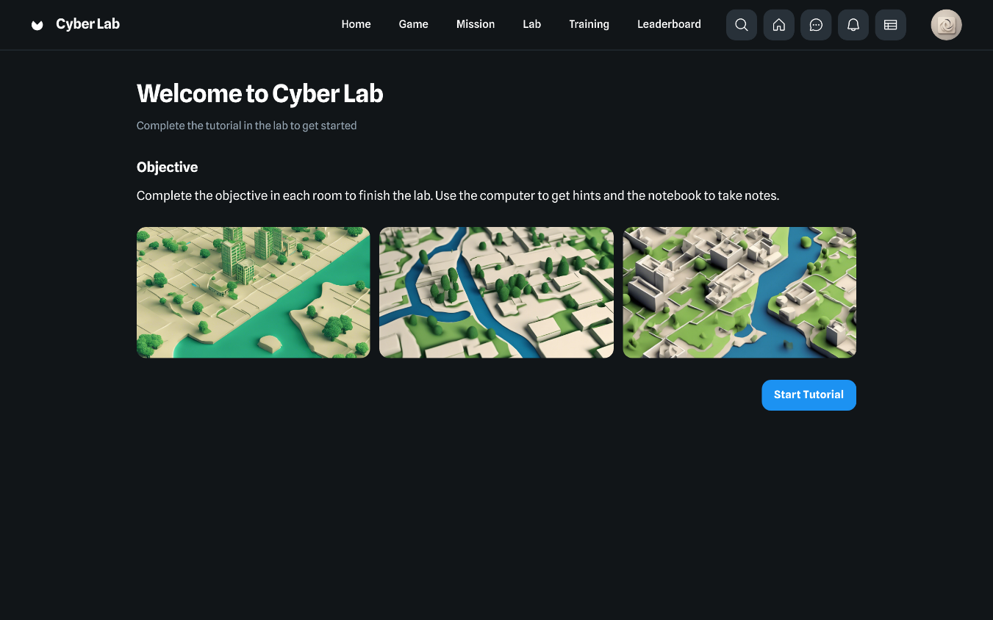

Figure 44 tutorial

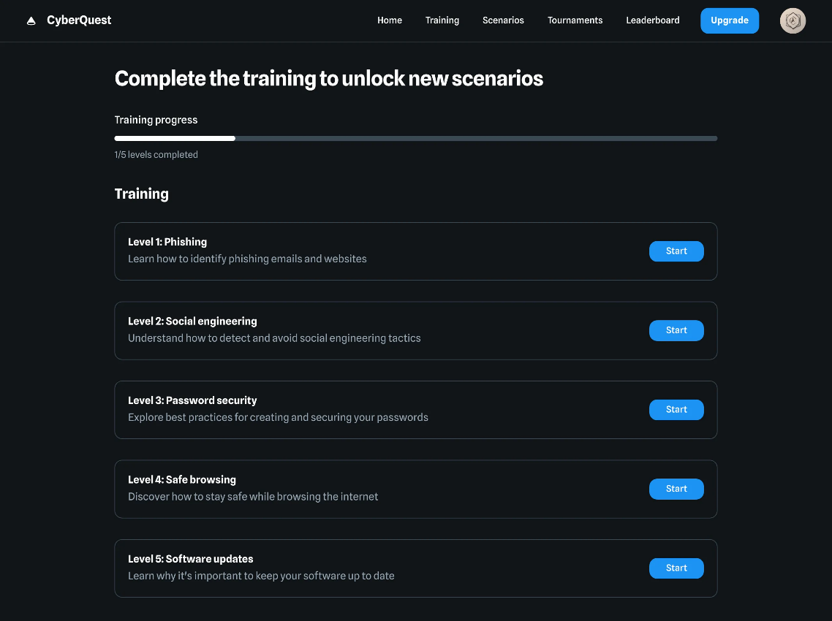

Figure 45 training level

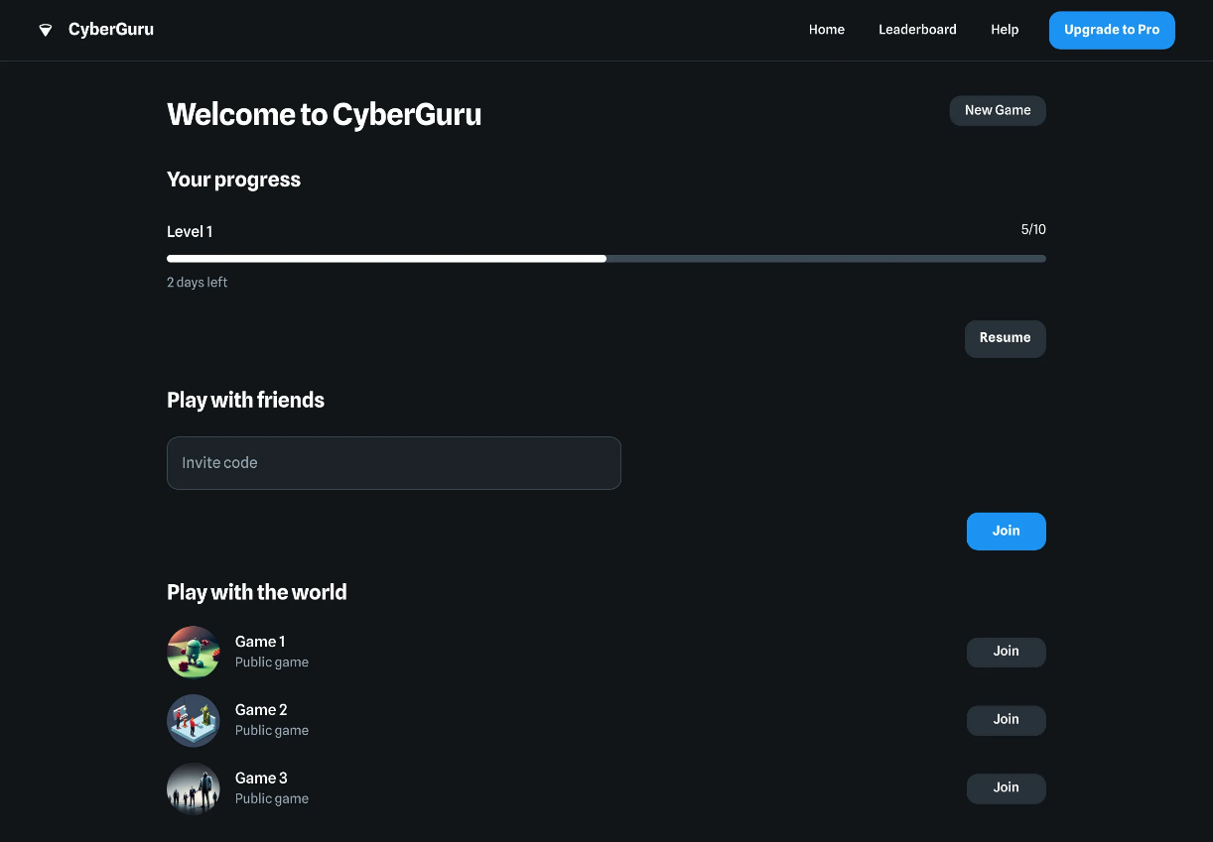

Figure 46 main game page

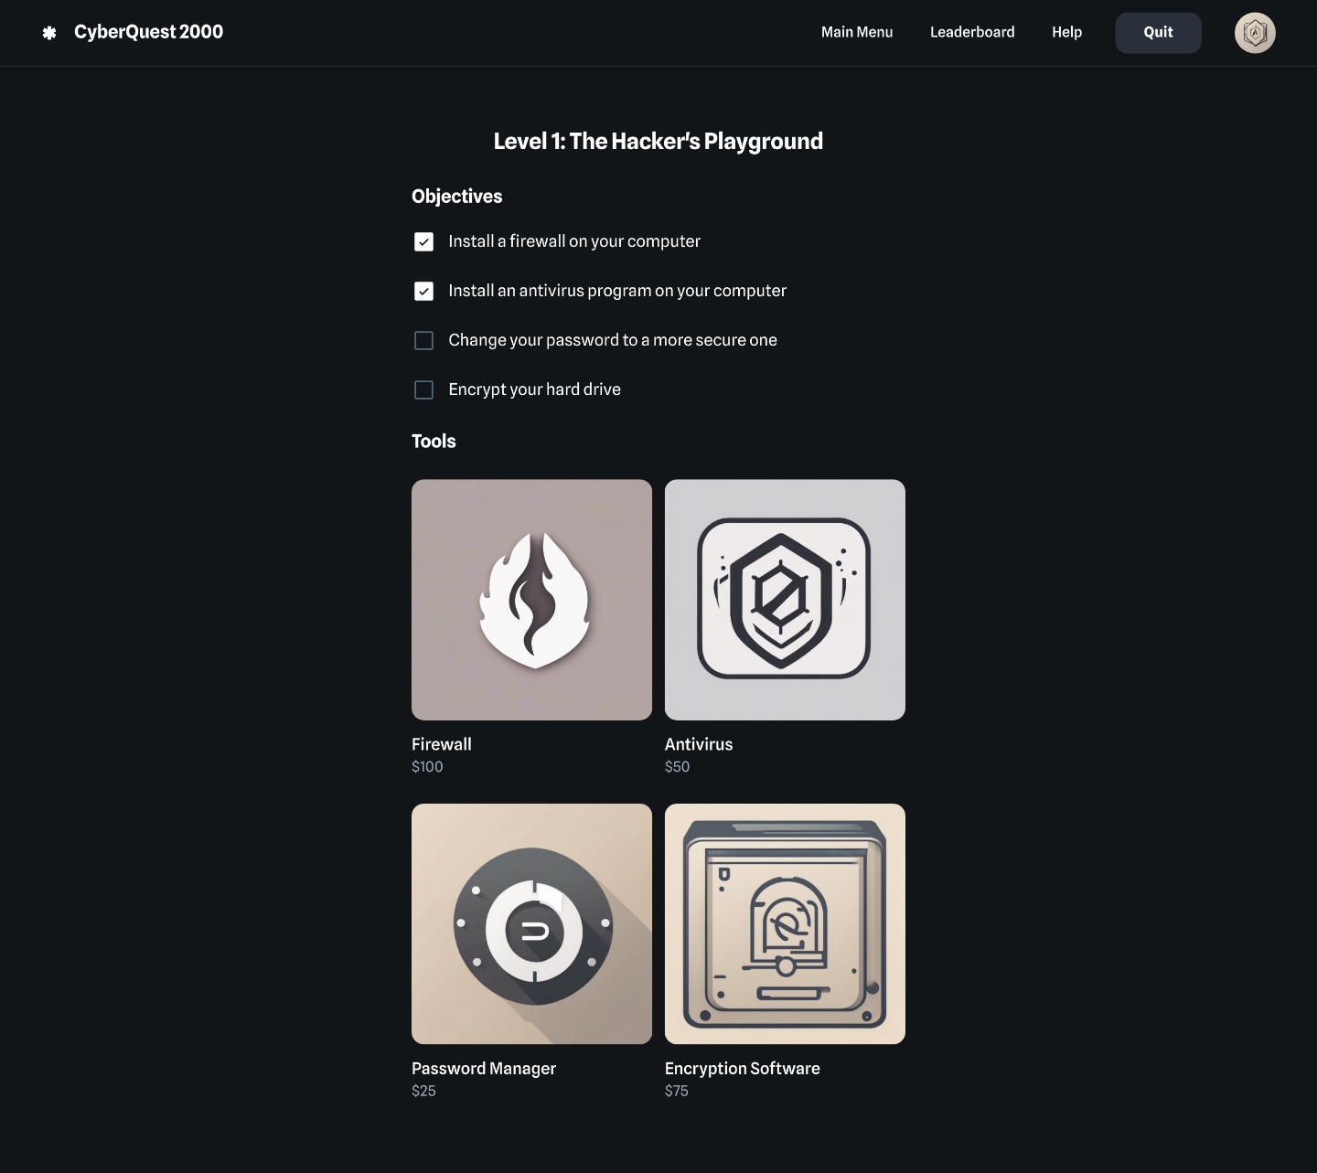

Figure 47 level page

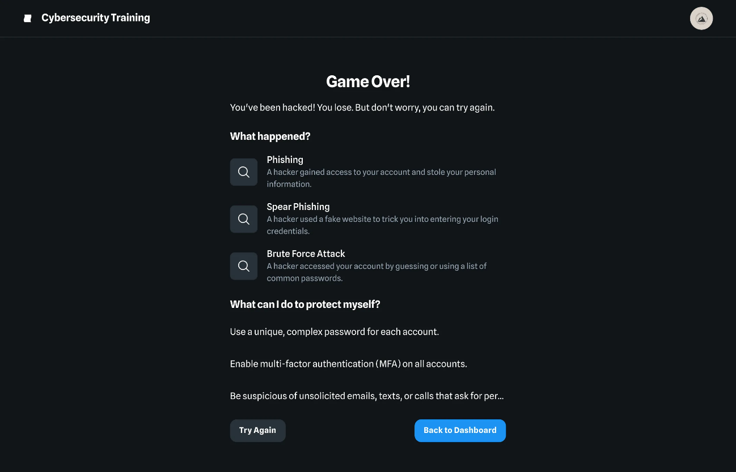

Figure 48 failed page

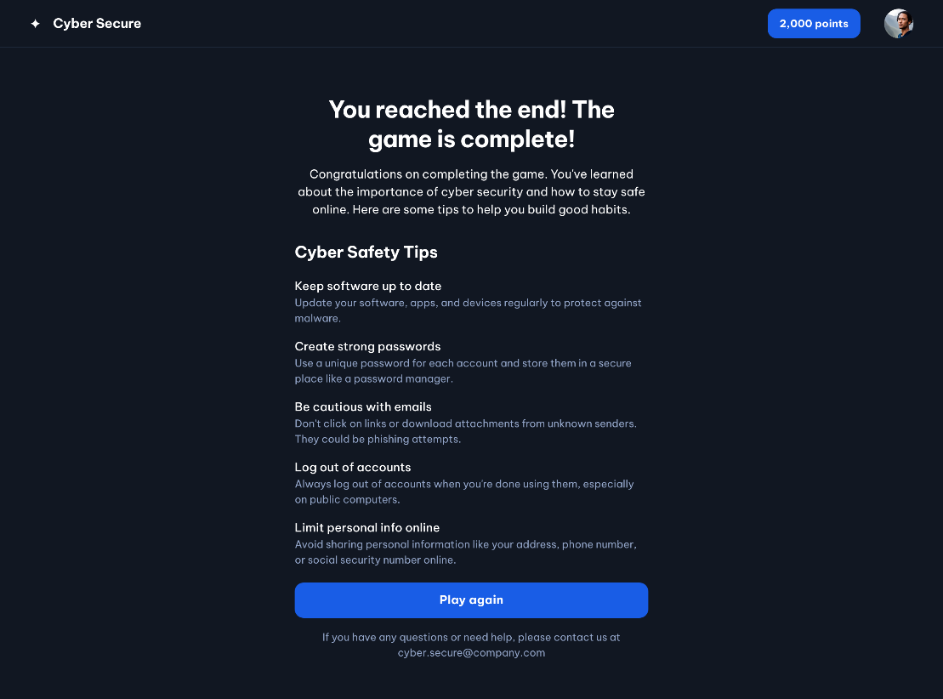

Figure 49 success page

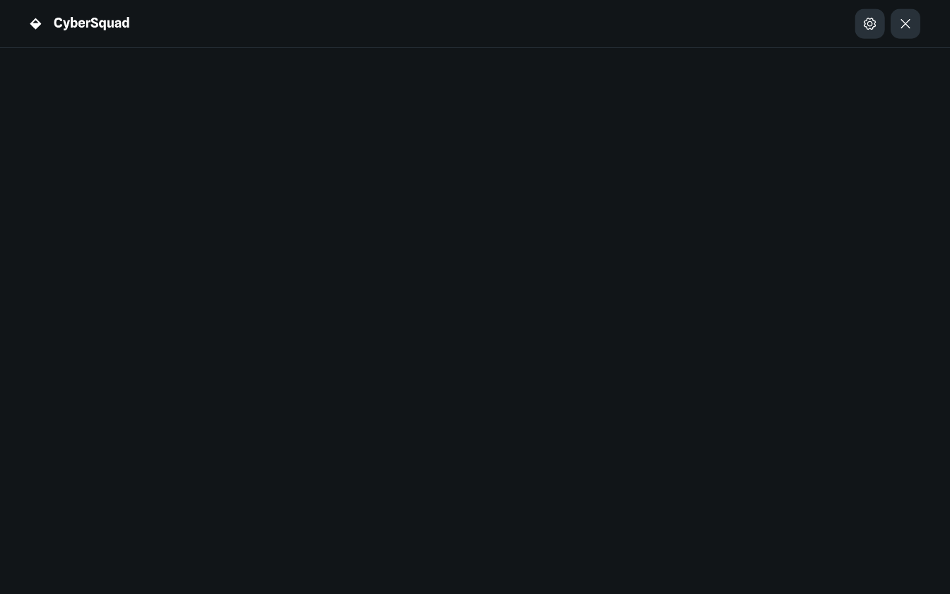

Figure 50 loading page

**3.16 Conclusion:**

In conclusion, our graduation project aimed to address the growing need for innovative cybersecurity education through the development of an educational cybersecurity game. By integrating engaging gameplay with fundamental cybersecurity concepts, we sought to create an immersive learning experience for users aged 13-30. Our research highlighted the importance of understanding the current cyber threat landscape, the target audience's needs, and effective gamification principles.

The project plan involved thorough background research, user-centered design, and iterative testing to ensure the game's relevance and effectiveness. Despite facing challenges such as time constraints, resource limitations, and the rapidly evolving field of cybersecurity, we remained committed to delivering a valuable educational tool.

Our game not only bridges the gap between theoretical knowledge and practical application but also makes learning about cybersecurity enjoyable and accessible. Through real-world scenarios and interactive challenges, users can develop the skills and awareness needed to navigate the digital world securely.

Ultimately, this project underscores the significance of gamified learning in enhancing cybersecurity education. By contributing to a safer online environment, we hope to empower individuals with the knowledge and tools to protect themselves and their digital assets from cyber threats.

**CHAPTER 4:**

**IMPLEMENTATION**

**4.1 Tools used to develop the project:**

**1.Unity:**

A robust game development engine, Unity provides all the necessary tools for creating, designing, and deploying interactive 3D and 2D games. Its intuitive interface and extensive library of assets and scripts allow developers to build games efficiently. Unity supports cross-platform development, making it easier to target multiple devices.

**2.Visual Studio Code:**

A lightweight and powerful source code editor, Visual Studio Code offers debugging, syntax highlighting, and code navigation features. It is highly customizable with plugins and extensions, enabling seamless coding and scripting for Unity projects.

**3.Adobe Photoshop:**

This tool was used for designing and editing graphical assets such as textures, backgrounds, and UI elements. Photoshop's advanced image manipulation features made it possible to create high-quality visuals for the game.

**4.GitHub:**

A version control system used to manage project files, track changes, and collaborate effectively among team members. GitHub helps ensure that all development progress is saved and accessible, providing a safeguard against data loss.

**5.Blender:**

A 3D modeling software used for creating custom 3D models and animations. Blender’s integration with Unity enables easy import/export of assets.

**6.Microsoft Word:**

Used for documentation purposes, Microsoft Word facilitated creating detailed design documents, user manuals, and other written resources for the project.

**4.2 code snippets:**

1. **Register & Log-in:**

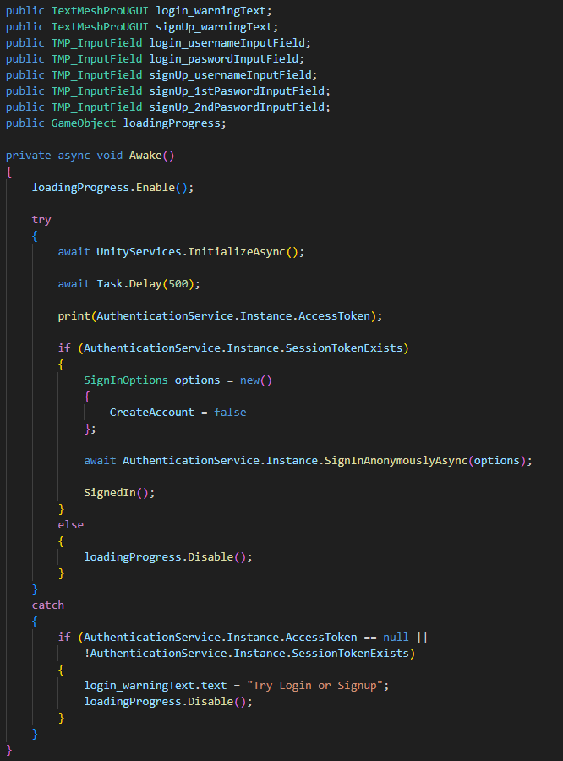

Figure 51 Register & Log-in code

This section explains the implementation of the **authentication process**, focusing on both user login and signup functionalities. It details the steps involved in validating user inputs, managing session tokens, and interacting with Unity Authentication Services. The code highlights how the system securely handles user credentials, validates email formats, and manages session states. Additionally, it demonstrates the integration with Unity’s backend services, ensuring seamless data synchronization and secure user account management. The snapshots illustrate the efficient flow from user input to backend processing, ensuring a reliable and user-friendly experience.

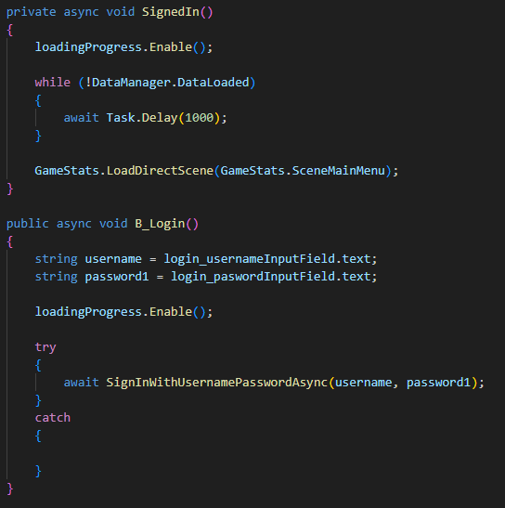

Figure 52 sign in code

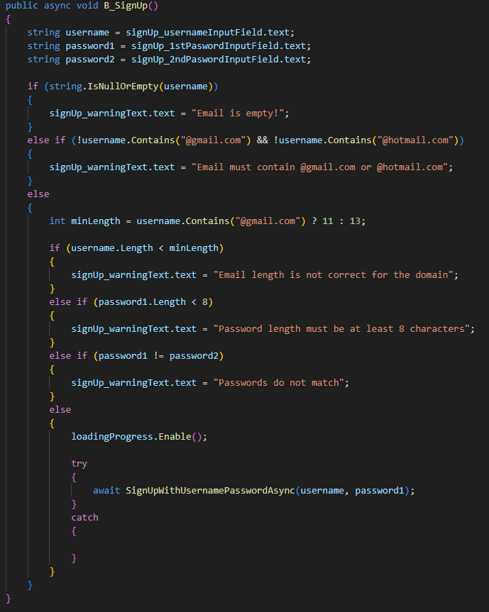

Figure 53 signup code

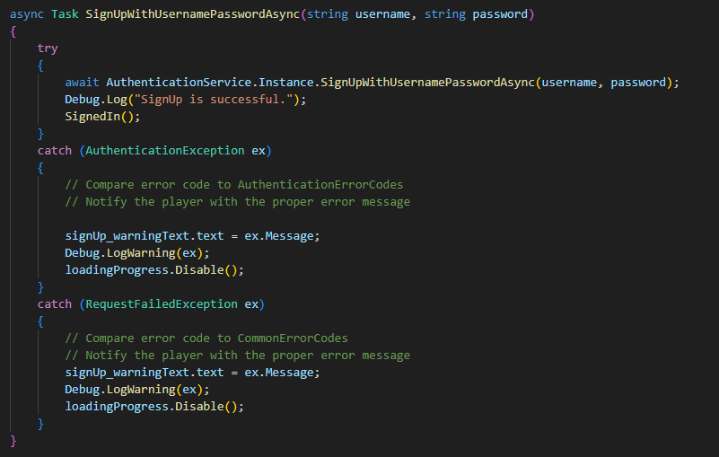

Figure 54 signup code

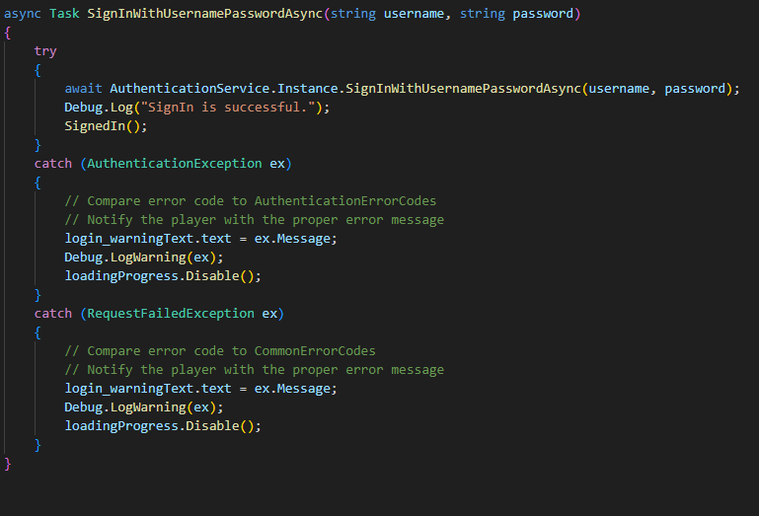

Figure 55 signup code

1. **Data Manager:**

**Database Program Used**

The project uses Unity Cloud Save, a part of Unity's Services, as the primary storage solution for saving and retrieving game data. Unity Cloud Save is a server-side storage solution provided by Unity, enabling developers to save data securely in the cloud without the need for a traditional relational or non-relational database setup like MySQL or MongoDB.

Unity Cloud Save simplifies managing game states, player progress, and other essential data by integrating seamlessly with Unity's ecosystem.

**Key Features of Unity Cloud Save in the Project**

**1. Data Structure:**

* Game data is serialized into JSON format using Newtonsoft.Json.
* The serialized JSON data is saved to Unity Cloud Save using CloudSaveService.Instance.Data.Player.SaveAsync().

**2. Saving Data**:

The Save() method in the DataManager class demonstrates how data is serialized and saved to Unity Cloud Save.

**Data Manager:**

This section outlines the implementation of the **data management system**, responsible for saving, loading, and resetting user data. The DataManager class acts as a central hub for handling game data, ensuring persistence and synchronization with Unity’s **Cloud Save Service**. The integration with Unity Authentication Services facilitates secure storage and retrieval of user progress, including level information, settings, and achievements. By serializing data into JSON format, the system efficiently stores and restores user data from the cloud, ensuring a consistent experience across sessions. The snapshots demonstrate how the DataManager interacts with the backend to manage user data seamlessly, emphasizing reliability and scalability.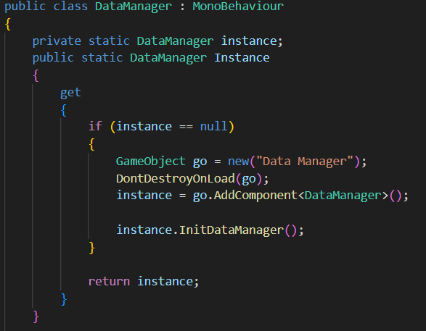

Figure 56 data manager code

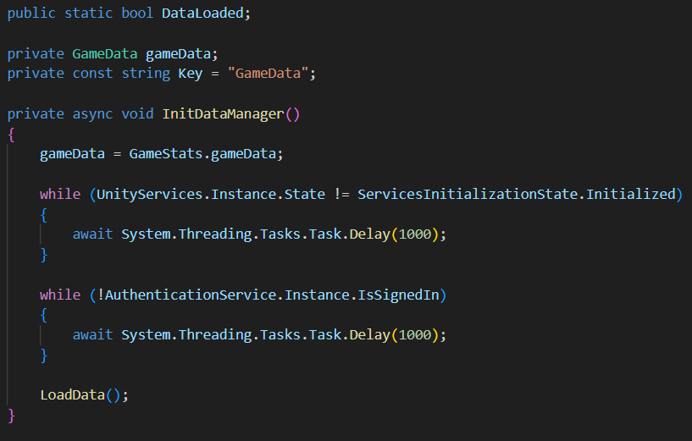

Figure 57 gamedata code

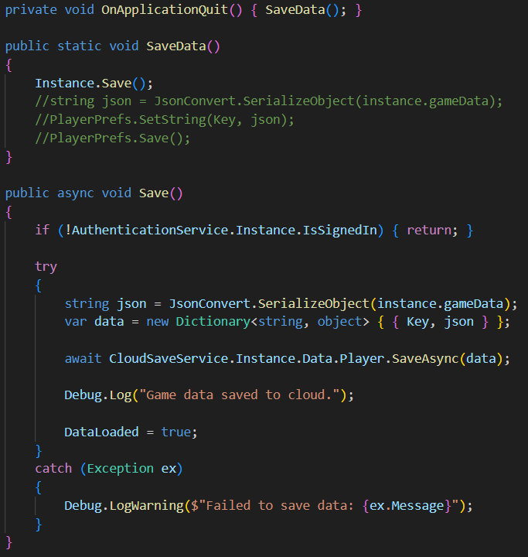

Figure 58 save data code

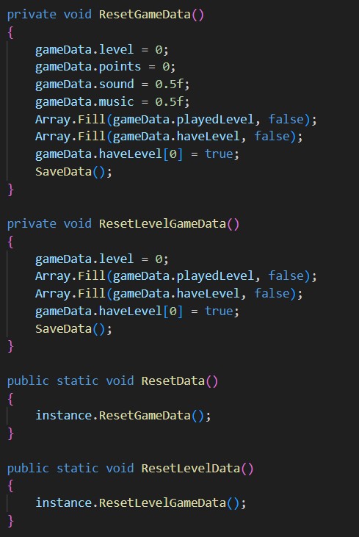

Figure 59 reset gamedata code

**Game Data:**

This section explains the structure and purpose of the **GameData** class, which serves as the blueprint for storing user-related data. Defined as a Unity **ScriptableObject**, this class encapsulates essential game properties such as audio settings, user progress, and level completion states. Its integration with the DataManager ensures efficient data handling, with fields like level, points, and arrays for playedLevel and haveLevel enabling precise tracking of user activity. The snapshots illustrate the modular design of the GameData class, showcasing how it organizes and provides access to user data for other components, ensuring scalability and maintainability in the system.

**Loading Data**:

The LoadData() method in the DataManager class retrieves and deserializes JSON data back into the GameData object.

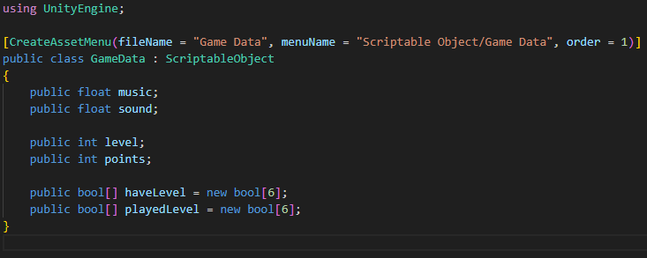

Figure 60 loading data code

**4.3 4.3 Test cases:**



**CHAPTER 5:**

**DATA ANALYSIS AND FINDINGS OR RESULTS**

**5.1 System Objectives Fulfilled:**

The Cyber Lab educational game has successfully achieved its primary objectives, as outlined below:

• Players can register an account with a username and password.

• Players can log in to continue their progress in the game.

• The game includes an authentication system that personalizes the player's experience and tracks progress.

• The game offers four interactive levels, each focusing on different aspects of cybersecurity:

o Level 1: Players learn to identify phishing emails.

o Level 2: Players understand and counter social engineering tactics.

o Level 3: Players detect and mitigate malware infections.

o Level 4: Players analyze and defend against DDoS attacks.

• Players receive feedback on their actions to improve learning and encourage replayability.

• A scoring mechanism tracks performance and provides motivation.

• The system ensures secure data handling for user accounts and progress.

**5.2 changed prototype:**

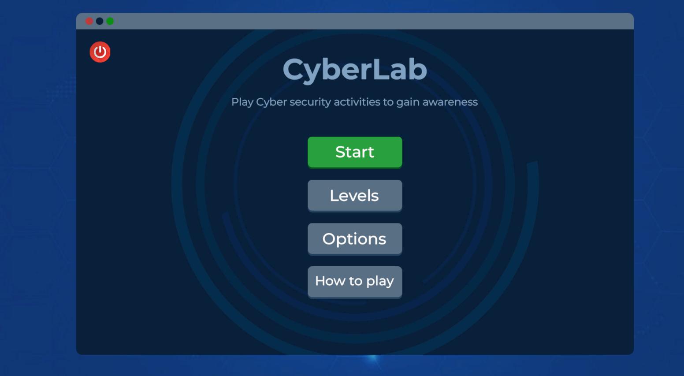



Figure 41 main menu

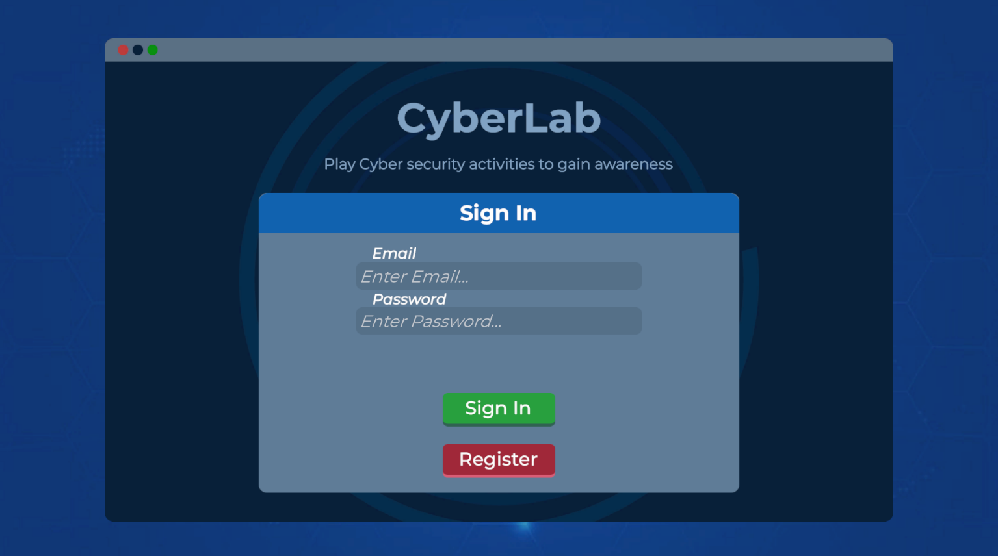

Figure 42 log in

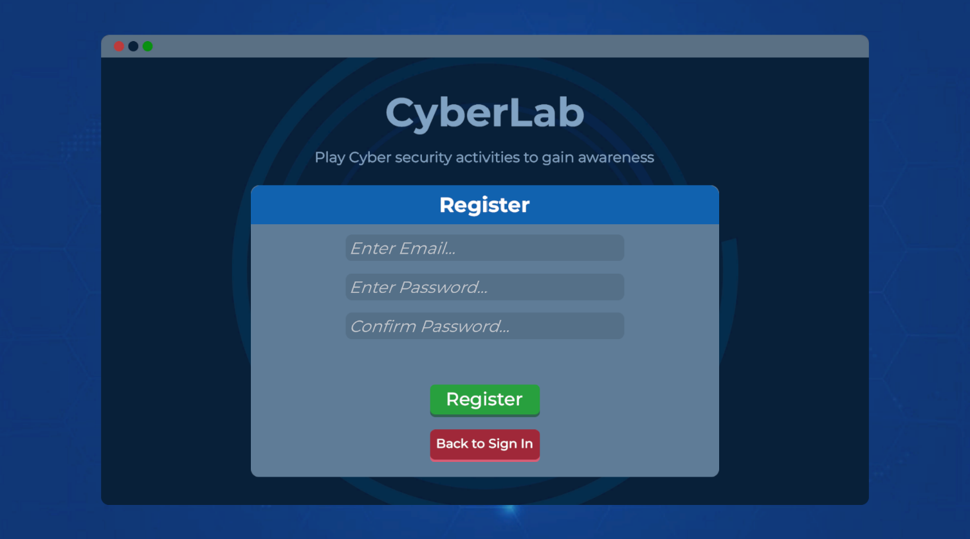

Figure 43 sign up

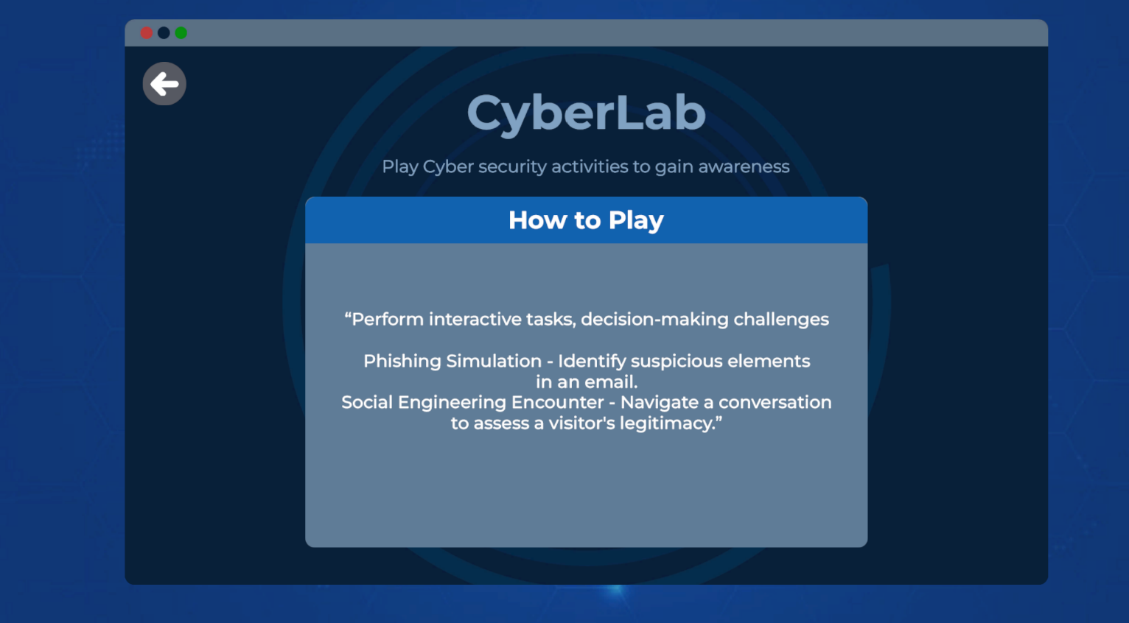

Figure 44 tutorial

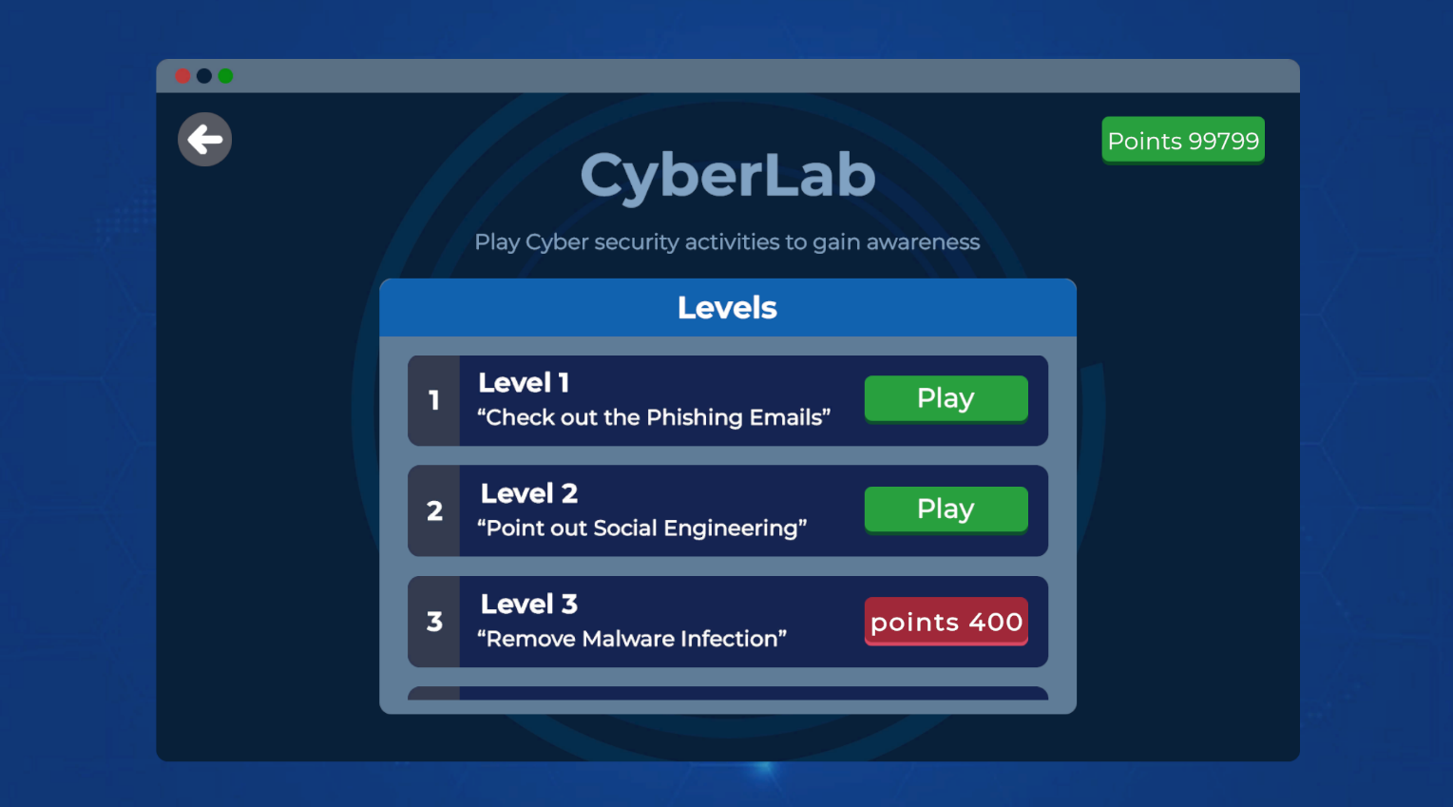

Figure 45 training level

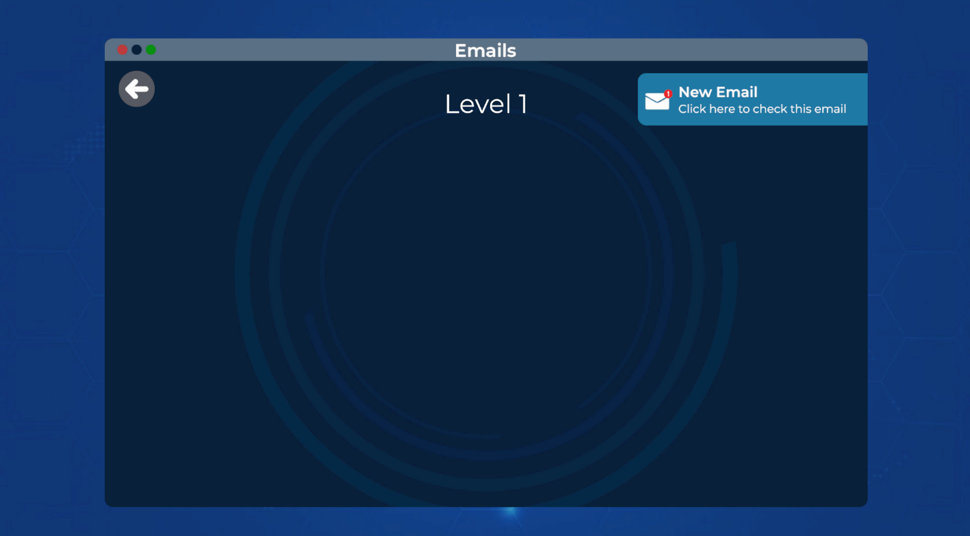

Figure 46 main game page

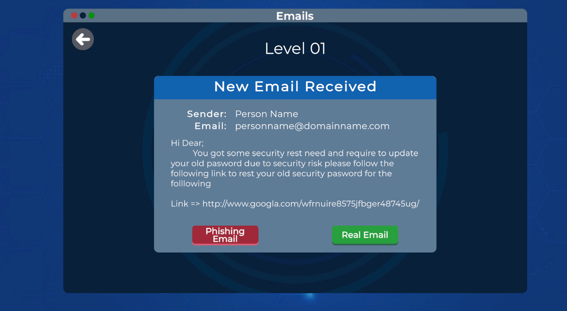

Figure 47 level page

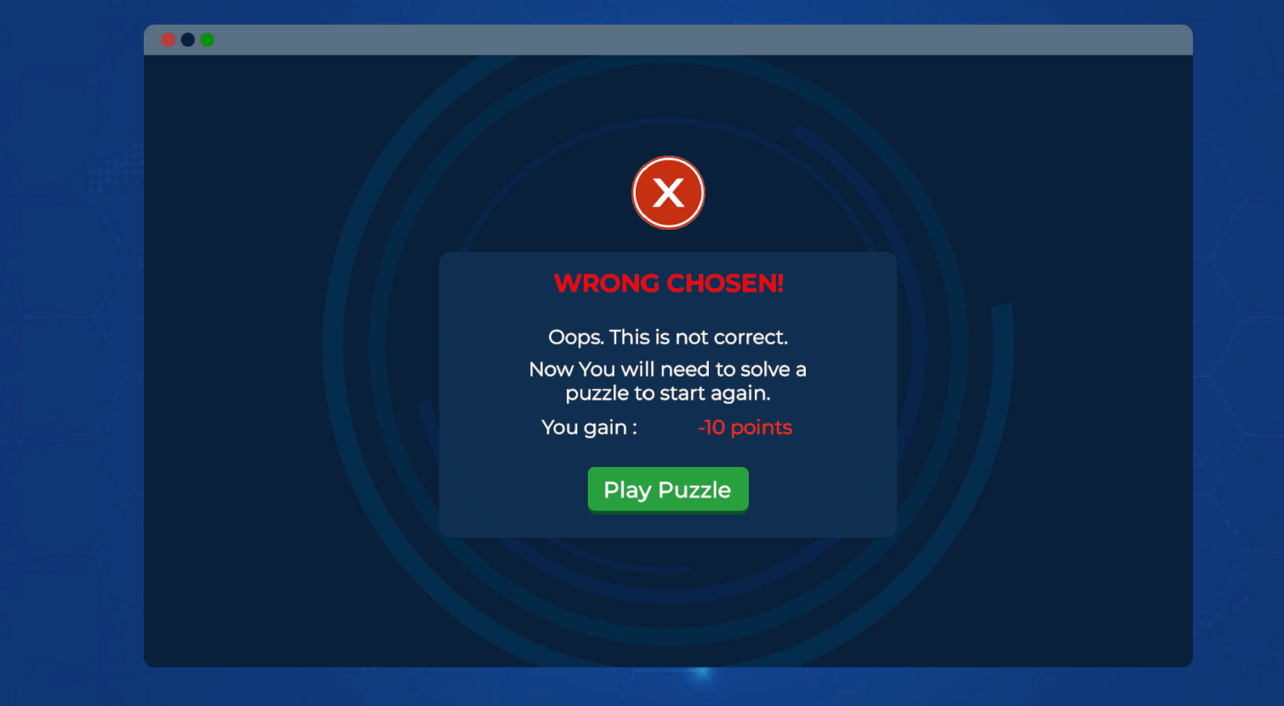

Figure 48 failed page

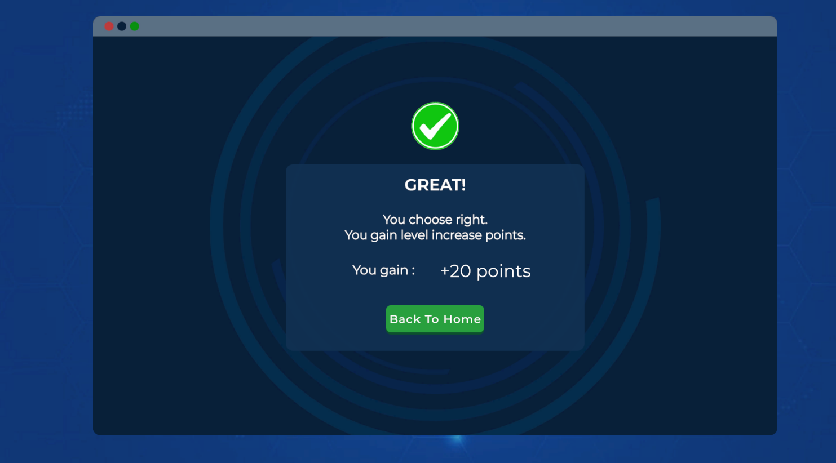

Figure 49 success page

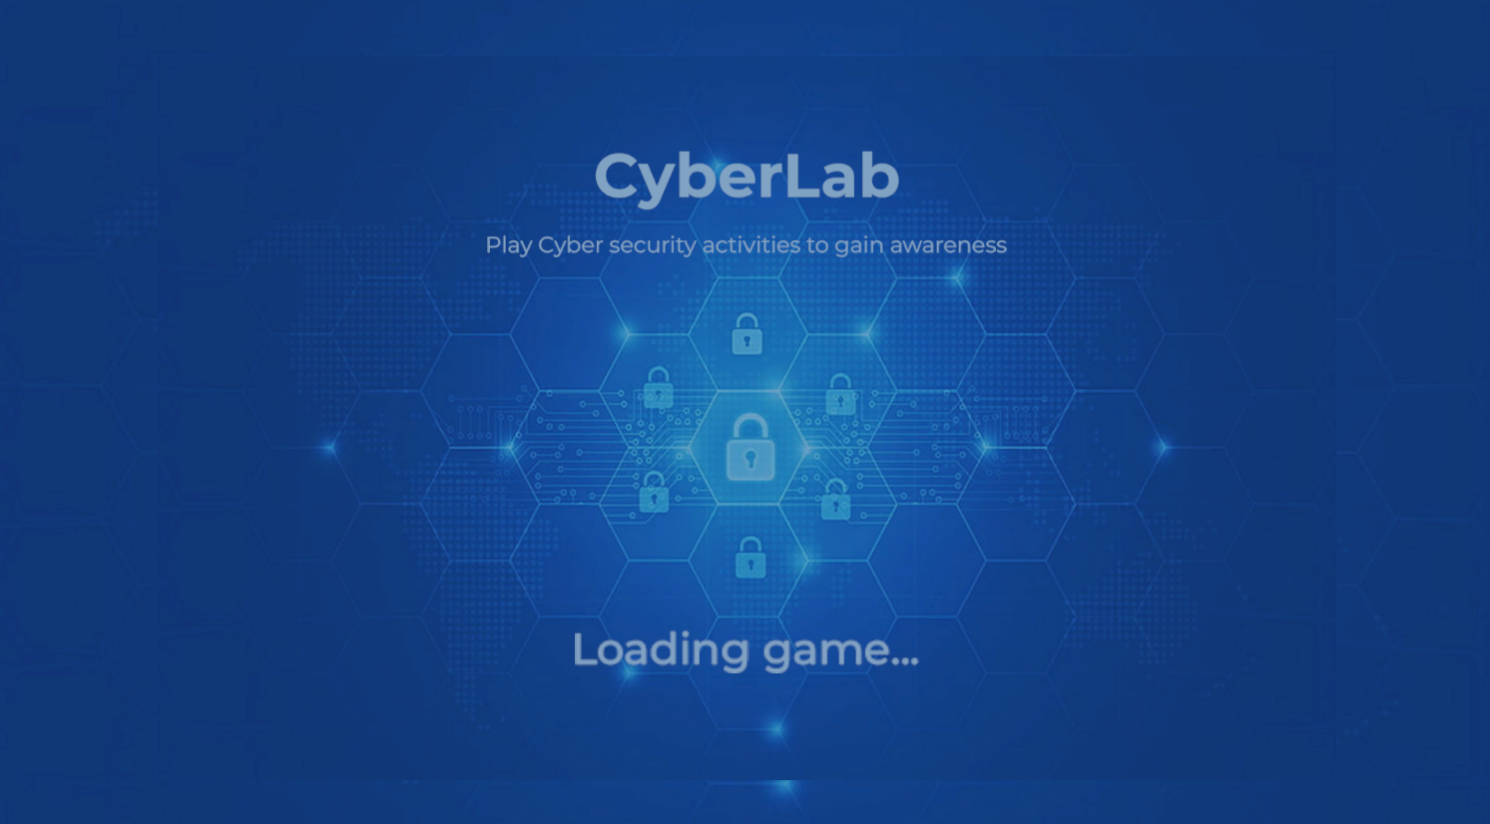

Figure 50 loading page

**CHAPTER 6:**

**CONCLUSION AND RECOMMENDATIONS**

**6.1 Conclusion:**

The Cyber Lab game prototype effectively provides an engaging platform for raising cybersecurity awareness. Through interactive gameplay and realistic scenarios, users can learn about critical cybersecurity threats and the best practices to mitigate them. Each level delivers unique educational experiences, making cybersecurity concepts accessible to a wide audience.

During the development process, we initially started using Unreal Engine 5 but were forced to switch to Unity. This change was necessary as Unity aligned better with the specific requirements of our game. Unity’s support for 2D game development made it a more suitable choice, allowing for smoother implementation of our gameplay mechanics and design vision compared to Unreal Engine's predominantly 3D-focused framework.

As with any project, challenges arose during implementation. Time constraints and debugging complexities required significant effort, but the primary goals of the system were successfully achieved.

**6.2 Suggestions for Future Research:**

For future improvements, we aim to expand our exploration to include other educational cybersecurity games to gain insights and enhance our own application. We plan to make the game easier to use by introducing visual guides, simpler interface designs, and tutorials for first-time users. Additionally, we aim to incorporate new features such as additional cybersecurity scenarios like ransomware or insider threats, and tools like a knowledge base for quick learning. We also hope to implement progress tracking, leaderboards, and a map-based feature to simulate real-world cyber-attack scenarios, enriching the educational experience and making it more engaging for users.

**6.3 Limitations of the game:**

Despite our best efforts, the program has certain limitations that we hope to address in future iterations:

**-Limited Scope of Topics**

While the game covers several key cybersecurity concepts, it does not encompass all areas of cybersecurity. Advanced topics such as secure software development, advanced encryption methods, or cloud security were beyond the scope of this project due to time and resource constraints.

**-Graphics and User Interface**

The game's graphics and user interface, while functional, are relatively basic compared to commercially developed educational games. This is primarily due to our limited experience in graphic design and animation, as well as resource constraints.

-**Scalability**

The current version of the game is not highly scalable. It is designed for a limited number of users and does not include features such as multiplayer functionality or integration with learning management systems (LMS). These features would require additional development time and resources.

-**Language and Accessibility**

The game is currently available only in English, which may limit its accessibility to non-English-speaking users. Additionally, while we aimed to make the game inclusive, we have not fully optimized it for users with disabilities, such as those requiring screen readers or other assistive technologies.

-**Evaluation Metrics**

While we included quizzes and challenges to assess users’ understanding of cybersecurity concepts, the evaluation metrics are relatively simplistic. More sophisticated methods, such as adaptive assessments or detailed progress tracking, could provide better insights into the learning outcomes.

-**Dynamic Content Updates**

The field of cybersecurity evolves rapidly, with new threats and best practices emerging regularly. The game does not currently have the capability to update its content dynamically, which could lead to outdated information over time.

**6.4** **Difficulties Encountered:**

-**Time Constraints**

The most significant challenge was the limited time available to complete the project. Developing an educational game that effectively integrates cybersecurity concepts into an engaging format required extensive research, design, coding, and testing. Some planned features, such as additional game levels or more complex scenarios, had to be excluded due to time limitations.

-**Resource Limitations**

As students working on a graduation project, our access to advanced tools, software, and high-performance hardware was limited. This affected the quality of certain aspects of the game, such as graphics and animations, which could have been more polished with better resources. Additionally, our budget constraints meant we had to rely on free or low-cost development tools.

-**Technical Challenges**

Developing a game with realistic cybersecurity scenarios required us to learn and implement advanced programming techniques, which were sometimes beyond our current skill set. For example, creating a secure and robust user authentication system and simulating real-world cyber threats presented significant challenges. Debugging and resolving issues during the development phase also consumed a considerable amount of time.

-**Balancing Education and Entertainment**

Striking the right balance between making the game educational and ensuring it remained entertaining was another major challenge. If the game was too focused on education, it risked becoming boring for players. On the other hand, if it prioritized entertainment, the educational value might have been diluted. Significant effort was spent fine-tuning this balance.

-**User Testing and Feedback**

Conducting user testing to gather feedback was challenging due to the limited availability of participants. While we managed to test the game with a small group, a larger and more diverse pool of testers would have provided more comprehensive insights into user engagement and learning outcomes.

**APPENDIX**:

We conducted a survey and 200 people participated, with 52% identifying as female and 48% as male. Below are the questions, answers, and a summary of the findings:

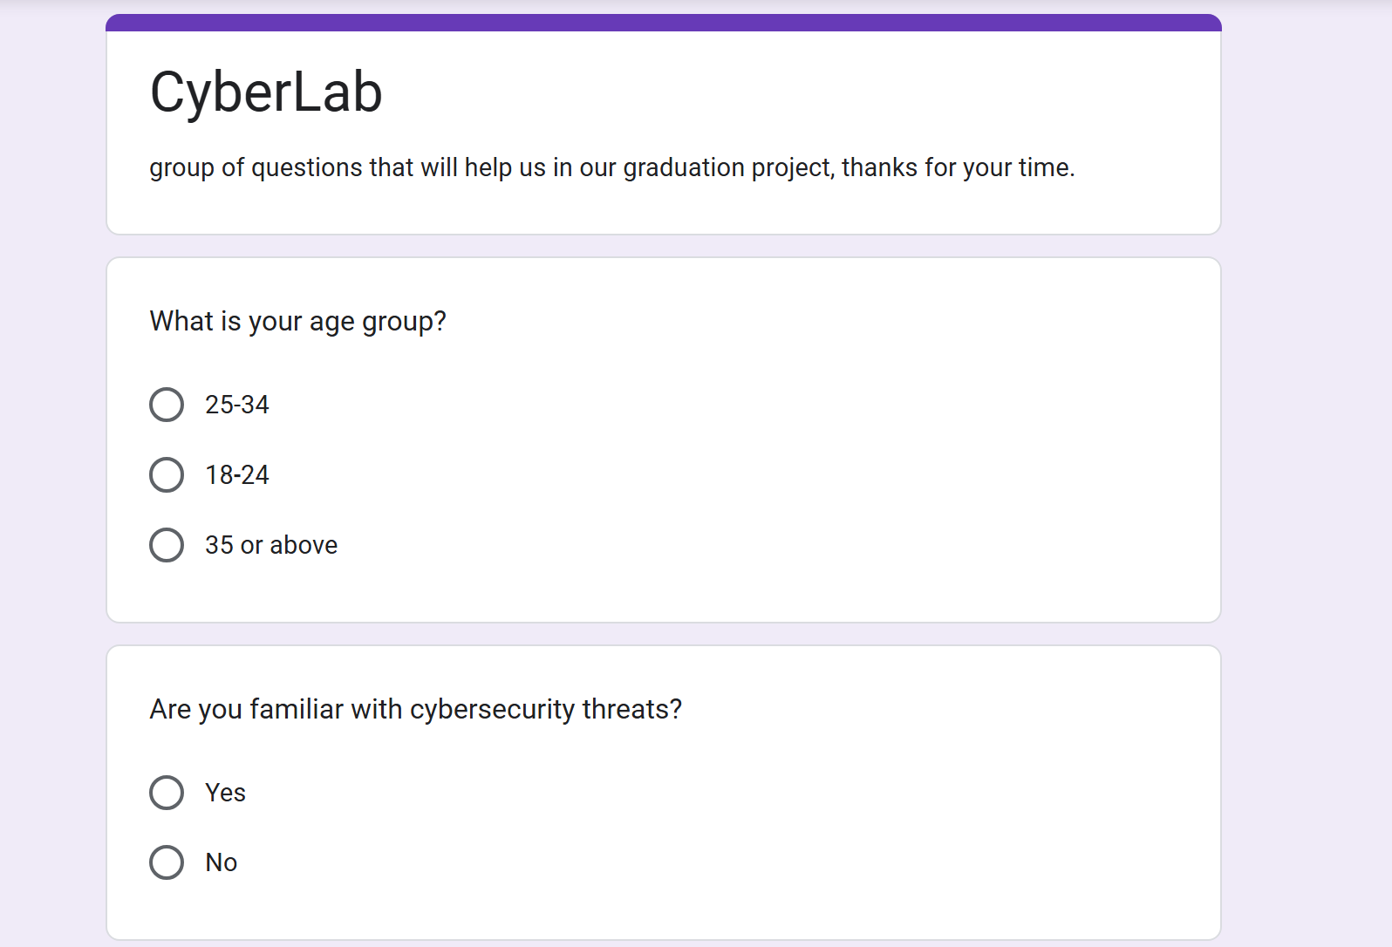

Figure 61 survey questions

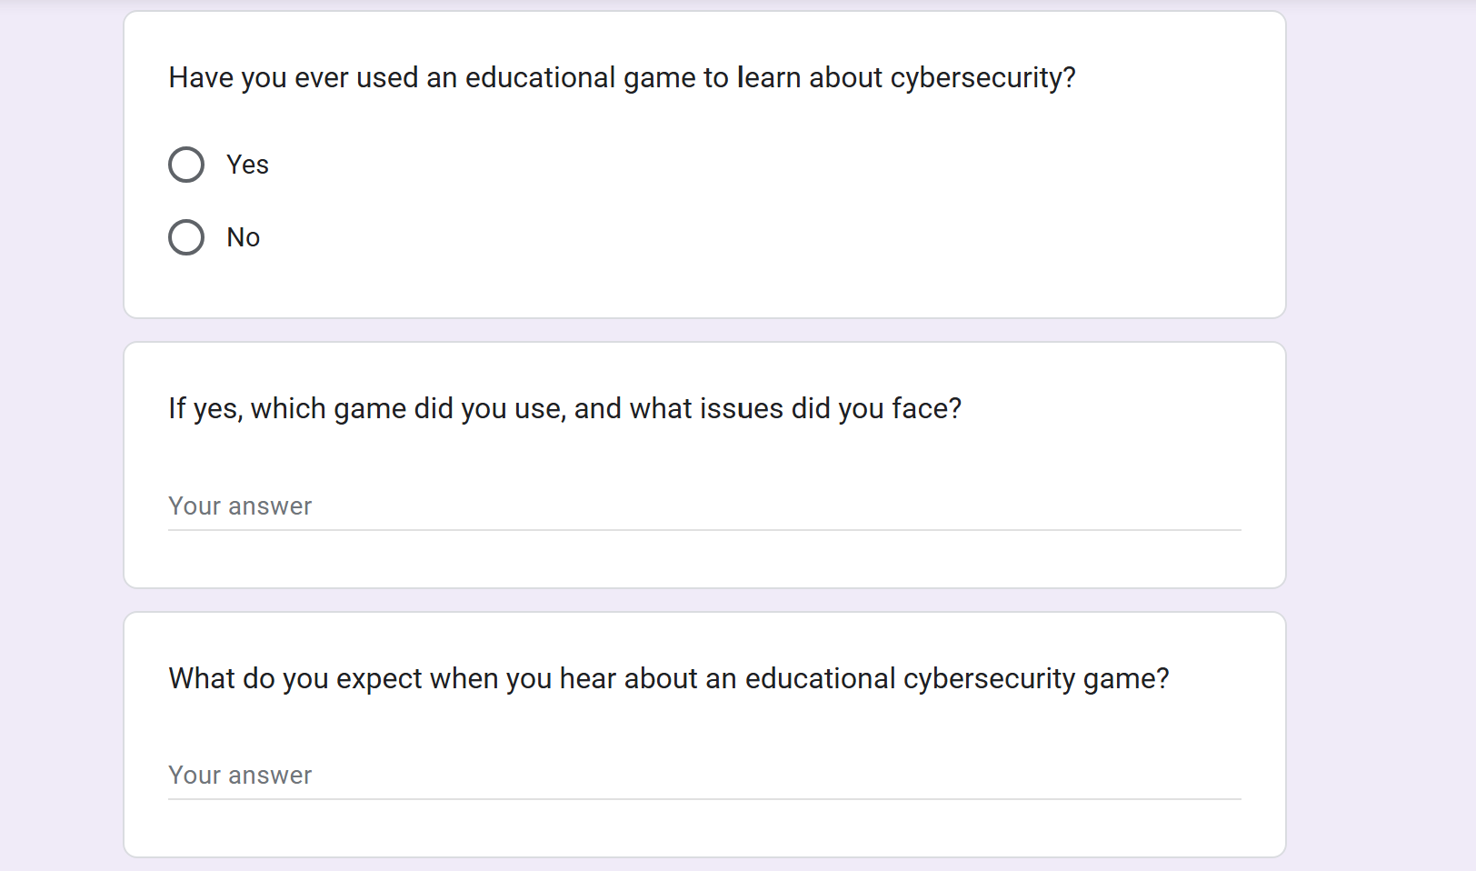

Figure 62 survey questions

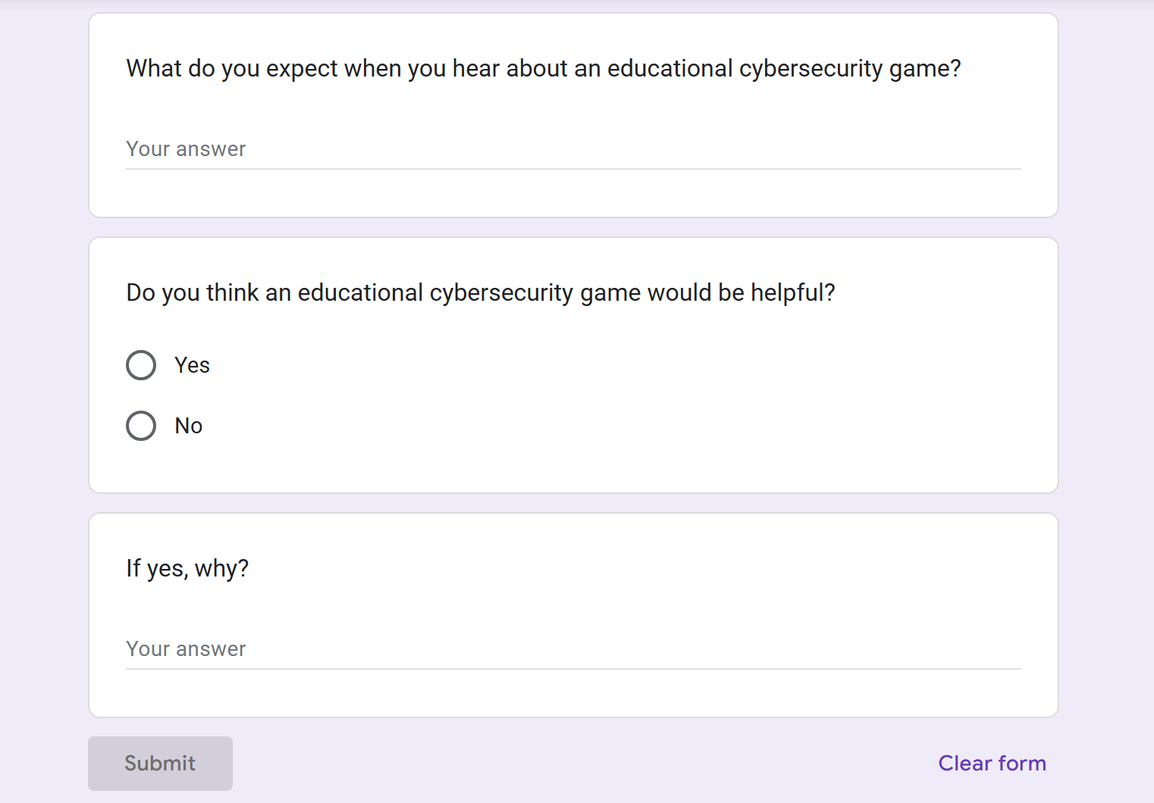

Figure 63 survey questions

1. **What is your age group?**
   * The majority of respondents were aged 25–34 (40%), followed by 18–24 (35%), and 35 or above (25%).
2. **Are you familiar with cybersecurity threats?**
   * 70% of participants indicated familiarity with cybersecurity threats, while 30% were not familiar.
3. **Have you ever used an educational game to learn about cybersecurity?**
   * 18% of respondents had used an educational game for cybersecurity learning, while 82% had not.
4. **If yes, which game did you use, and what issues did you face?**
   * Some participants mentioned games like Cyber Awareness and Threat Simulator.
   * Common issues included lack of interactivity, outdated scenarios, and complex interfaces.
5. **What do you expect when you hear about an educational cybersecurity game?**
   * The responses included expectations such as:
     + Real-world scenario-based gameplay.
     + Tutorials and guides for ease of use.
     + Inclusion of phishing, malware, and DDoS attack levels.
     + Progress tracking and scoring for motivation.
     + Visually engaging and interactive experiences.
6. **Do you think an educational cybersecurity game would be helpful? If yes, why?**
   * Yes: 90%
   * No: 10%
   * Notable comments:
     + "Interactive games make learning engaging and effective."
     + "Such games can help bridge the cybersecurity knowledge gap."
     + "It encourages awareness and provides practical insights."

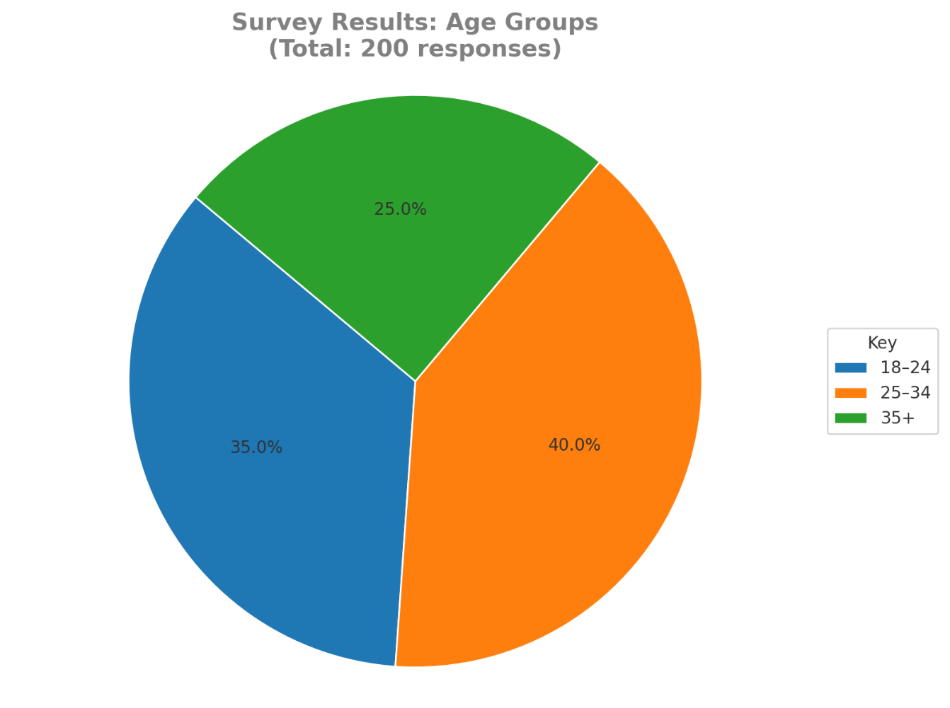



Figure 64 survey "age"

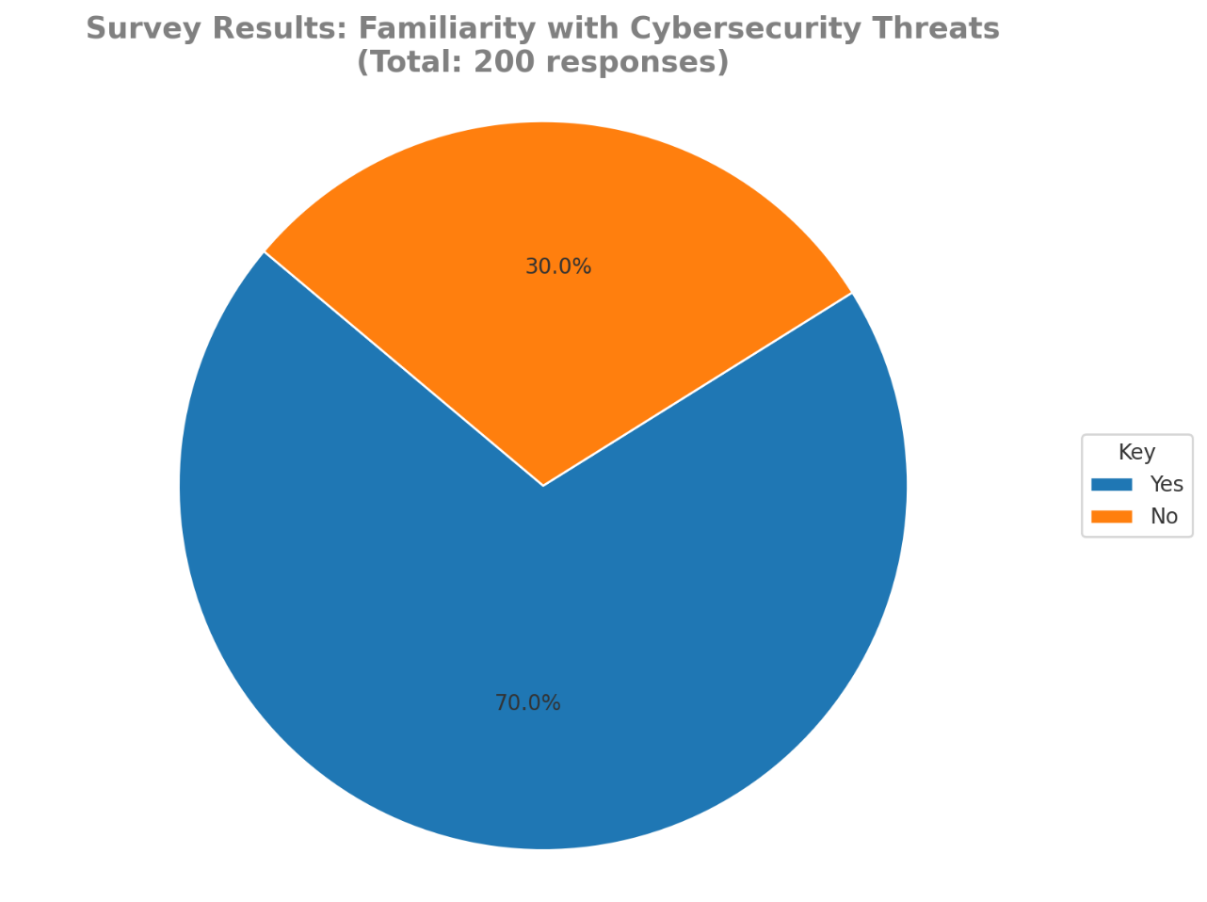

Figure 65 familiarity with cybersecurity threats

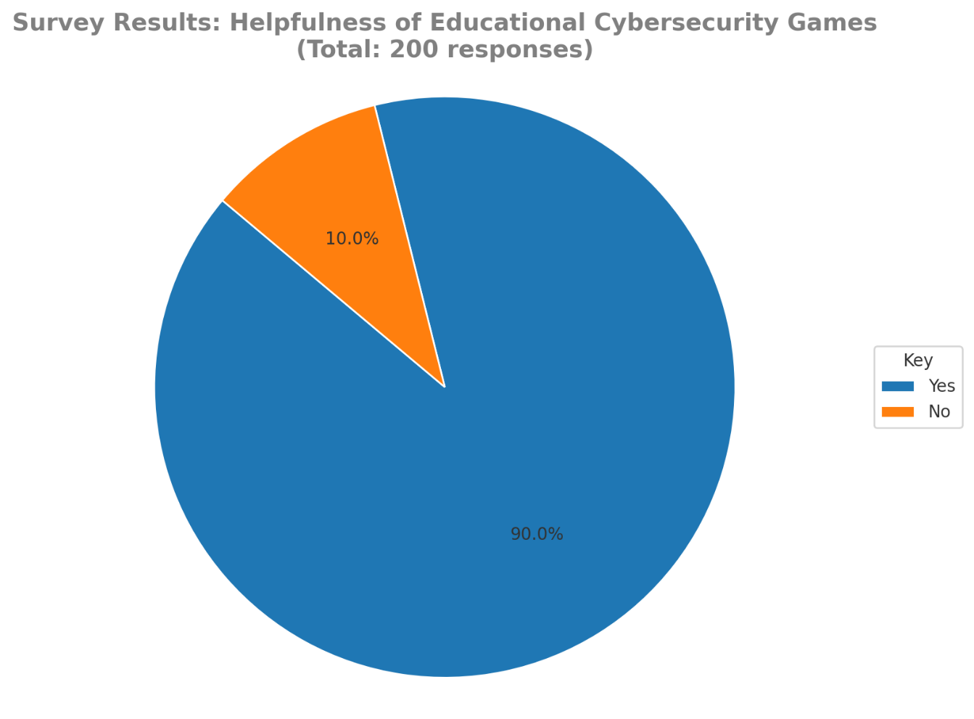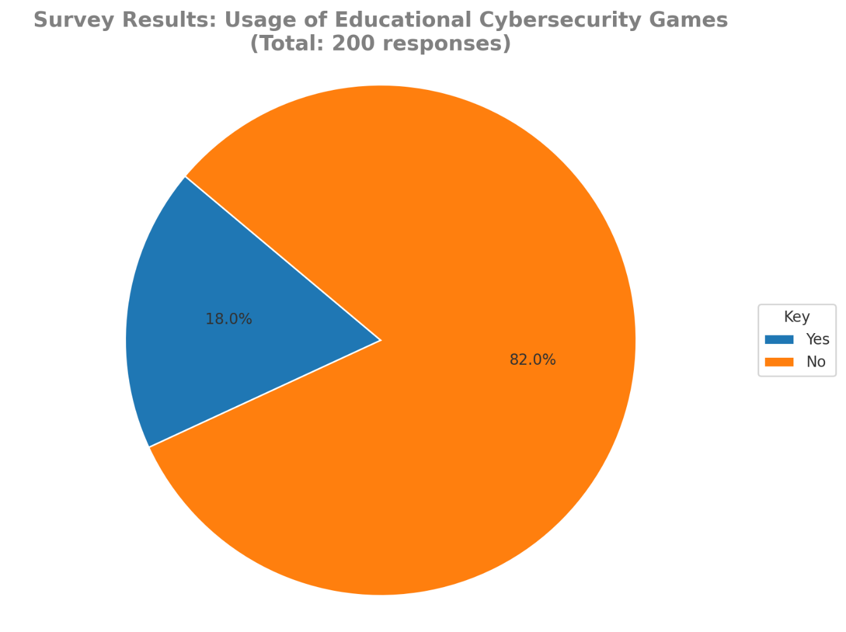

Figure 66 helpfulness of educational cybrsecurity games

Figure 67 usage of educational cybersecurity games

# References

|  |  |
| --- | --- |
| [1] | LaterON, "Cybersecurity Essentials: Protecting Your Digital Life," Youtube, 22 12 2023. [Online]. Available: https://m.youtube.com/watch?v=QzH_38F6z6E. |
| [2] | W. i. a. LLC, "Cybersecurity 101: Protecting Your Business Against Cyber Threats," Youtube, 19 7 2023. [Online]. Available: https://m.youtube.com/watch?v=TdqkqxVgJTY. |
| [3] | B. Whisperer, "The Significance of Cybersecurity in Protecting Our Digital Frontier (5 Minutes)," Youtube, 27 9 2023. [Online]. Available: https://m.youtube.com/watch?v=HFZw1cOMDxE. |
| [4] | EC-Council, "Cybersecurity Resilience: The Key to Critical Infrastructure Protection," Youtube, 18 12 2023. [Online]. Available: https://m.youtube.com/watch?v=D5Amld79C0U. |
| [5] | A. S. Inc, "Fortify Your IoT Security: Key Solutions to Protect Your Connected World | Algoworks," Youtube, 12 9 2023. [Online]. Available: https://m.youtube.com/watch?v=t9RXHs6ZZ54. |
| [6] | M. Ninaus, "Systematic review article," frontiers, 28 9 2020. [Online]. Available: https://www.frontiersin.org/articles/10.3389/feduc.2020.611072/full. [Accessed 29 1 2021]. |
| [7] | A. Manzano-leon, "Between level up and game over:a systematic literature review of gamification in education," Mdpi, 11 12 2020. [Online]. Available: https://www.mdpi.com/2071-1050/13/4/2247. [Accessed 10 2 2021]. |